Cloud Platform

on-demand delivery of computing resources/services to the world is called "cloud computing"

What is a software application?

Software applications are written in a programming language, that contains set of instructions to be executed to meet the business requirements of the organization/owner

programming language

1. java

2. .net

3. python

4. php

5. ruby

6. scala

The software applications can be majorly categorized into 5 different types

1. standalone applications

2. distributed web applications

3. enterprise applications

4. mobile applications

5. batch-processing applications

depends on the type of the application we deliver the application to the enduser

#1. standalone application/desktop application

standalone applications are even called as desktop application or single user applications which are downloaded/installed and executed locally on a computer system.

1.1 Single user can use the application at onetime

1.2 They use the resources of the computer and execute locally

1.3 The user has to install the application software to use it.

#2. Distributed Web Applications

These applications are even called client-server technology applications.

The distributed web applications servers webpages or html pages over the network offering information or business service of an organization

The distributed web applications can be categorized into 2 types

1. static web applications

The static web applications comprises of only HTML/web content that will be served to the enduser. These applications are non-interactive and enduser cannot pass information as an input to perform operation. always the same data will be served to the enduser no matter how many times the user accessed

2. dynamic web applications

These are the applications that allows the enduser to interact by passing data as an input to them through HTML Forms, reads the data perform operation and returns response back to the user

To build dynamic webapplication we need a backend programming language

1. java

2. .net

3. php

4. python

5. perl

6. scala

7. ruby

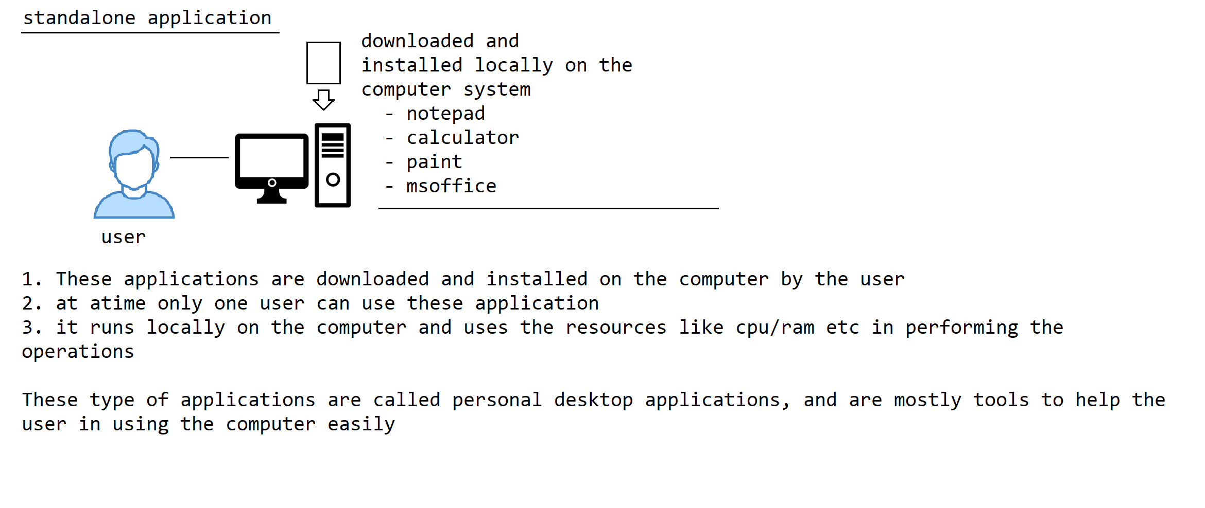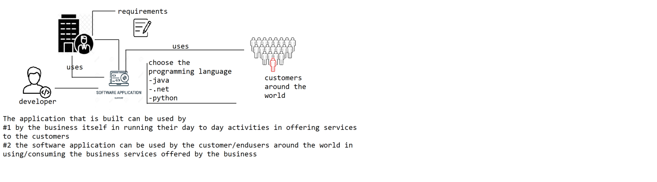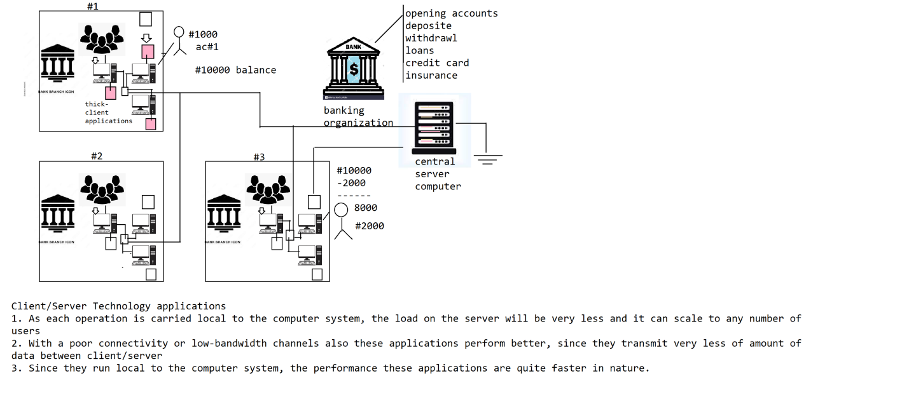

What is an software application, why do we use it?

Software applications are written using programming languages comprises of instructions that are executed to meet the requirements of a business organization/system/entity.

There are 5 types of software applications are there

1. Standalone/Desktop applications

2. Distributed web application

3. Enterprise application

4. Mobile application

5. Batch Processing Systems

#1. Standalone/Desktop applications

These are single-user applications that are installed and executed locally on the computer system. At a time only one user can use the application.

These applications directly takes the data as an input from the keyboard of the computer through the user, performs the operation and prints the output to the Console or output devices attached to that system.

#2. Distributed Web applications

These are the application that are accessible over the network and exchange HTML/Web content over the network

There are 2 types of web applications are there

1. static web application

2. dynamic web application

#2. dynamic web application

What are dynamic web applications, how do they look like, why do we need to use them?

What are client-server architecture based applications, how do they work?

In the client-server architecture based applications there are 2 parts are there

1. client program

2. server program

#2. Server program

The server program is the located centrally and is accessible to all the client programs. The server program does minimal processing and is used for distributing the data across all the client programs

#1. Client program

The client program is the thick client program, it is installed on a computer and connects and communicates over the network to the server program to retreive data and perform operation. The client will access the data from the server program by communicating over the network and performs operation locally on the client computer and stores/pushes the data back onto the server to distribute/share the data with others

advantages:

1. The operations are carried at the local to the client application, so that the load on the server is less and performance of system is very high

2. By nature these client-server applications exchanges very less amount of data, so that these applications are idle suitable to work on low-bandwidth communication channels as well

dis-advantages:

1. The client programs are thick client applications that consumes the cpu/memory to perform operations on the client computer, we need high-end machines at the client side. So the cost of setting up the infrastructure required in running these applications are quite high

2. The client application has to be installed on each client computer, setting/installing the application on each computer within the organization is going to take lot of time.

3. We need a dedicated IT team, required to be available 24X7 in monitoring, installing, configuring and maintaining the applications across the organization. The cost of maintainance of these client programs are pretty much high

4. Different branches of the organization has different computers of varied hardware configurations and operating system platforms, the client application that is being built may not work across all the hardwares or operating system platforms. It is tough to achieve compatibilty in running the software application across varied architectures

5. Patching and upgrading the client software program across all the machines of the organization is very difficult and requrires huge amount of time and cost

6. since the processing/operations takes place at the client-side achieving data consistency is very difficult

How to overcome the above problems?

To overcome the above problems, the distributed web applications are introduced.

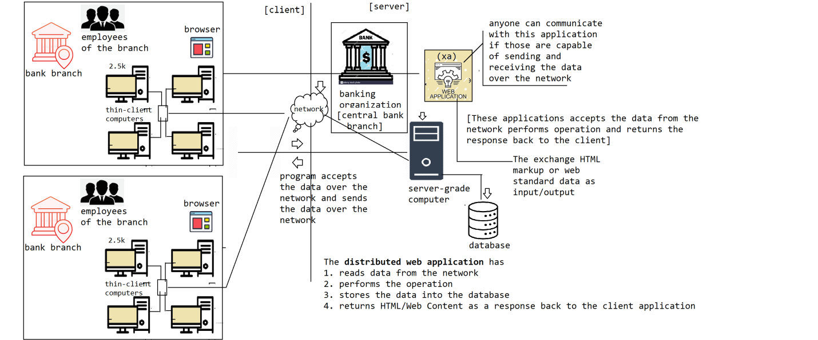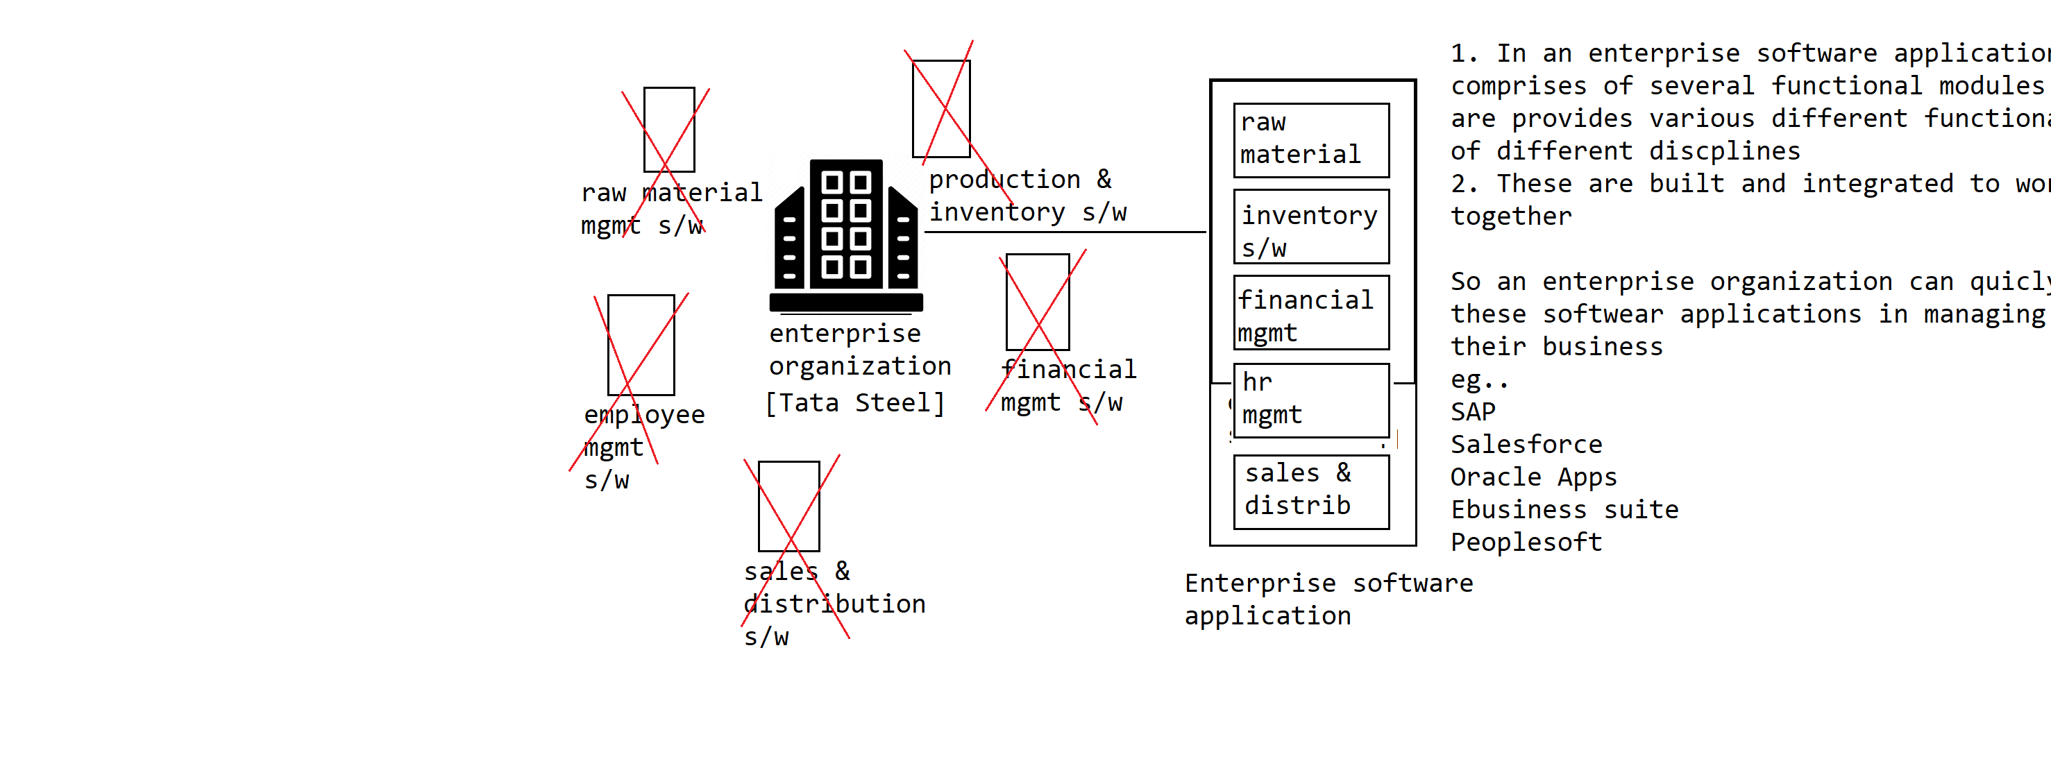Distributed web applications

In a distributed applications, there are 2 parts are there

1. server

In a distributed web application the server computer will be running with an web application, that can take the web request over the network from the client. then performs operation and returns an HTML/Web page as a response back to the client.

The whole business logic/processing is centrally located on the server computer only

2. client

The client is a thin-client application, the application will not perform any operation at the client-side, the client application just collects the data from the enduser, sends the data over the network to server application. and receives response from the server and displays to the user

if we see, the client-applications doesnt consume any cpu/memory in performing operations, so these are called thin-client applications. A web browser can act as an thin-client application to be installed and used at client computer

advantage:-

1. To run the thin-client application we can use thin-client machines/computers which doesnt have any cpu or huge memory in running these browsers. So, the cost of setting up the infrastructure required for running the thin-client application is very less

2. No need to install the thin-client application on the thin-client station, as the web browsers are the default software that comes as part of the system itself. So we dont need to spend lot of time on installing and configuring the client application on the computer.

3. There is no need of upgrading/patching the thin-client software which saves huge amount of maintainance cost

4. As we can use any browser software to access the server application, we dont see any compatible issues interms of hardware architecture or operating system platform in using the application

5. No need of a dedicate IT Support team to monitor, maintain and install the client s/w applications

dis-advantage:-

1. if the network brokes down the whole system/business goes down, so we always need an backup line to ensure we have the connectivy 24/7 which is quite expensive to maintain

2. we need high-speed internet/data line to communicate with the server. as the huge volumes of data will be transmitted between the server/client programs

3. if the server computer brokes down, the whole system goes down, so we need to ensure always we have multiple servers on which application is running for high-availability

4. If more users are communicating with server/application, then the load on the server will be high and results in performance degradation. so we need to ensure we run our application on multiple servers to handle the load

There are 5 types of applications are there

1. standalone / desktop applications

2. distributed web applications

3. enterprise applications

4. batch processing applications

5. mobile applications

#3. Enterprise applications

Enterprise application refers to very large application which comprises of multiple functional modules that are required for running an enterprise business system.

We can classify the applications broadly into 5 categories or types

1. standalone application

2. distributed web application

3. enterprise application

4. batch processing application

5. mobile application

#3. enterprise application

An enterprise application is nothing but a very large scale application that comprises of several modules catering to various different functionalities of the business.

These modules are pre-built and are integrated to work with each other sophisticatedly

#4. batch-processing application

batch processing systems works with large volumes of data being processed in batches and produces the desired output

--------------------------------------------------------------------------------------------

How to host an distributed web application to the public world?

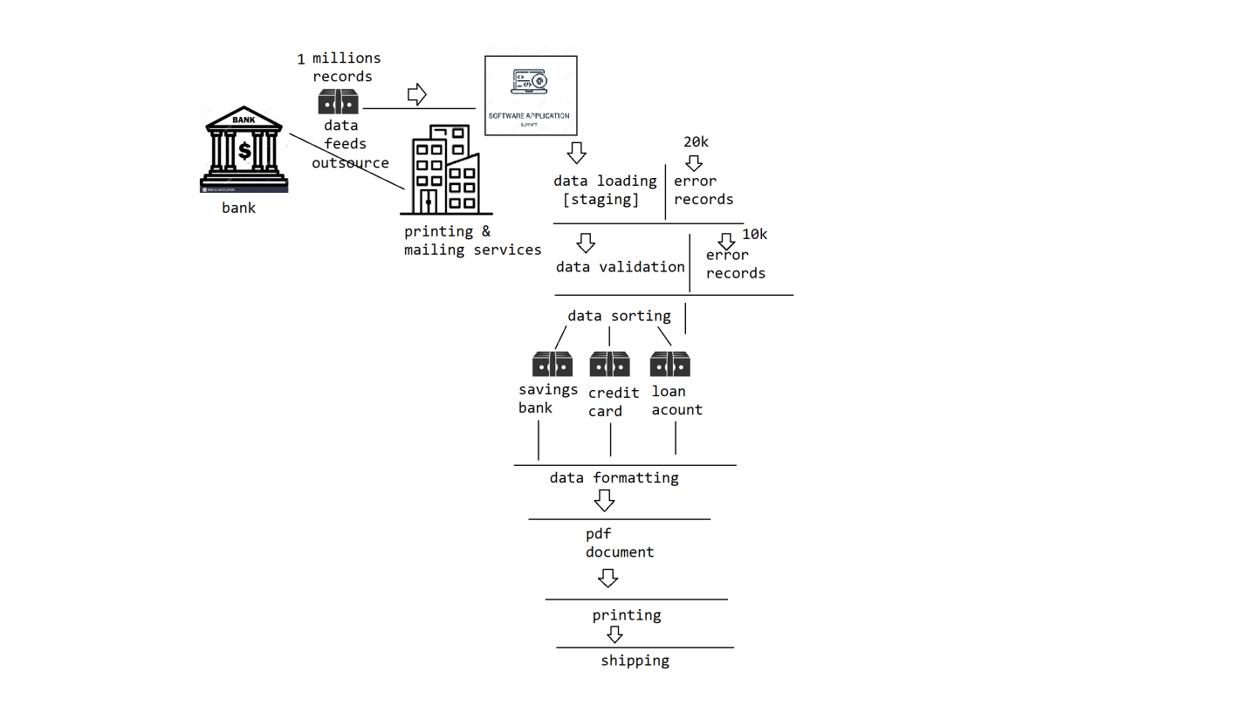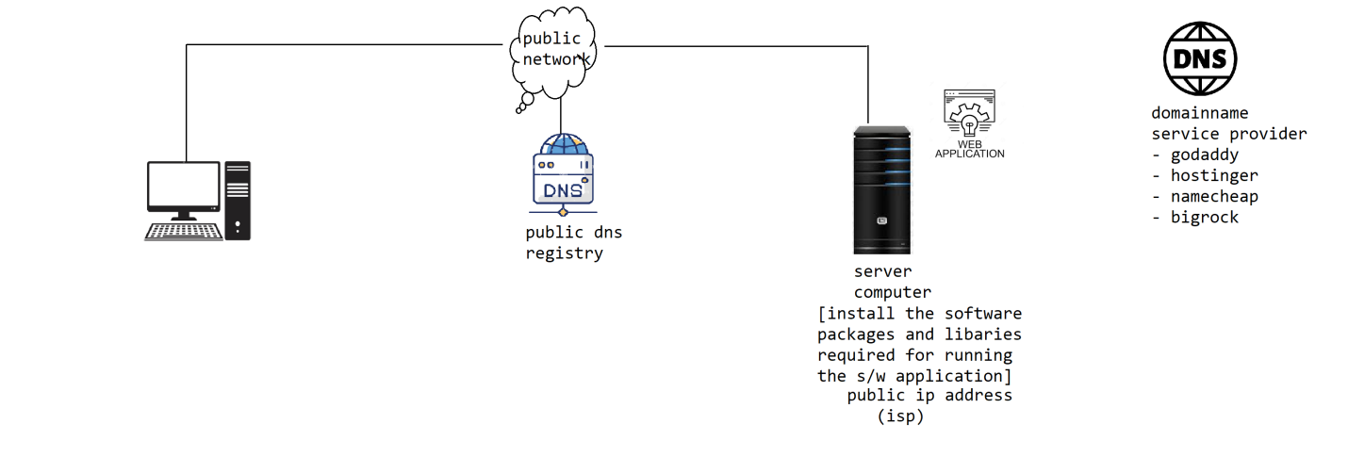How many types of applications are there?

We can classify the software applications broadly into 5 types

1. standalone or desktop application

2. distributed web application

3. enterprise application

4. mobile application

5. backend application

How to host an distributed web application to the public world?

Hosting an application is a process of making the application live or accessible to the people around the world. To make an application accessible to the people around the world we need to do 2 things

1. we need a hosting space or a computer on which we should be able to run our application

2. we need a domain name registered with a dns registry to route the request to our application

How can we host an application to the world, where can we get the hosting space?

There are many ways we can host an application let us explore

#1. Inhouse hosting

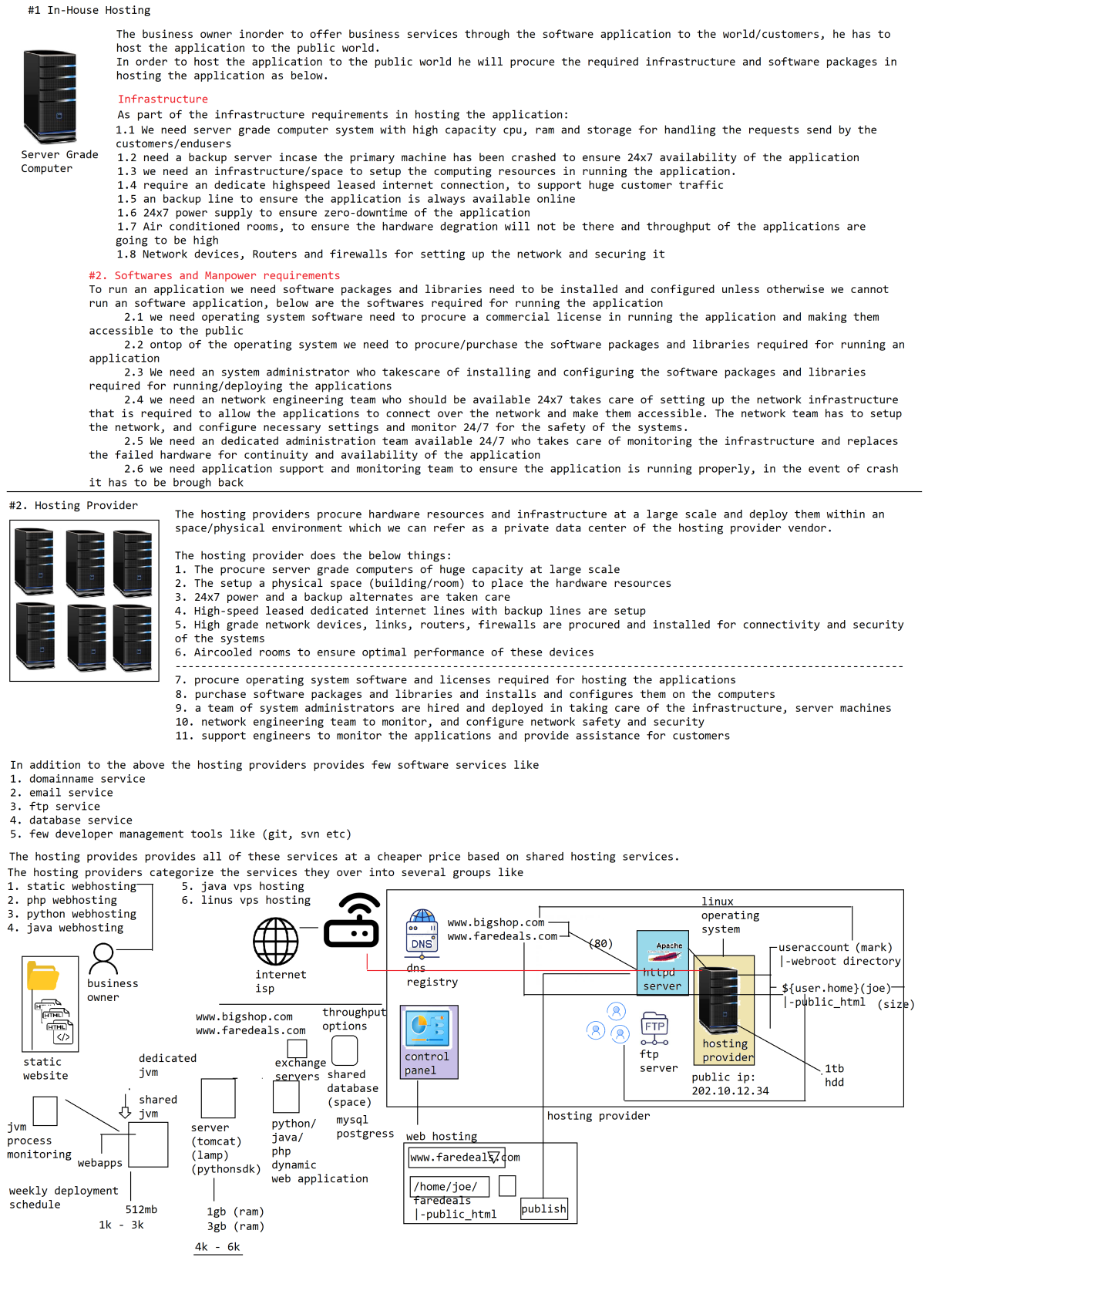How to host an distributed web application and make it accessible to the world?

Hosting is the process of making the application accessible to the world. In order to host an application there are many options are available.

Let us explore how can the applications can be hosted prior to cloud.

#1. In-House hosting

The business owner in order to offer business services to the customers around the world, he has to host the application. For which in an in-house hosting,the business owner itself procures required infrastructure and software for hosting the application as below.

There are 2 main aspects required for hosting an application

1. Infrastructure

1.1 We need server grade computer system with high capacity cpu, ram and storage for handling the requests send by the customers/endusers

1.2 need a backup server incase the primary machine has been crashed to ensure 24x7 availability of the application

1.3 we need an infrastructure/space to setup the computing resources in running the application.

1.4 require an dedicate highspeed leased internet connection, to support huge customer traffic

1.5 an backup line to ensure the application is always available online

1.6 24x7 power supply to ensure zero-downtime of the application

1.7 Air conditioned rooms, to ensure the hardware degration will not be there and throughput of the applications are going to be high

1.8 Network devices, Routers and firewalls for setting up the network and securing it

#2. Softwares

To run an application we need software packages and libraries need to be installed and configured unless otherwise we cannot run an software application, below are the softwares required for running the application

2.1 we need operating system software need to procure a commercial license in running the application and making them accessible to the public

2.2 ontop of the operating system we need to procure/purchase the software packages and libraries required for running an application

2.3 We need an system administrator who takescare of installing and configuring the software packages and libraries required for running/deploying the applications

2.4 we need an network engineering team who should be available 24x7 takes care of setting up the network infrastructure that is required to allow the applications to connect over the network and make them accessible. The network team has to setup the network, and configure necessary settings and monitor 24/7 for the safety of the systems.

2.5 We need an dedicated administration team available 24/7 who takes care of monitoring the infrastructure and replaces the failed hardware for continuity and availability of the application

2.6 we need application support and monitoring team to ensure the application is running properly, in the event of crash it has to be brough back

The in-hosting of an application is also called as "on-premise" hosting where the application is being deployed/hosted at the client/businessowner environment itself. it has lot of drawbacks/dis-advantages with in-house hosting

dis-advantages/drawbacks:-

1. The cost of investment required for setting up the infrastructure, procuring the software license in hosting the application is very huge

2. The initial setup required in setting up the infrastructure resources and software packages in hosting the application takes lot of time at an average of 30-45 days time needed to bring up the machines for hosting the applications for eg..

1. we need the space to be setup with required infrastructure

2. power cabling need to be done for handling the load

3. airconditioned to be setup

4. power backup and generators need to be deviced

5. lan cabling need to be done

6. leased internet lines has to be procured

7. hardware assembling, network setup and configurations has to be taken care

3. we need to hire manpower or relevant expertise required for carrying all the above operations which takes lot of time

4. we need to maintain the administrators, network engineers and application supports engineers to monitor and manage applications which is going to inccur huge maintainance cost

5. the cost of procuring the software licenses in running the application is very high

6. we need to perform necessary validations/verifications to ensure our network/systems are safe and are not prone to any security breach

From the above we can understand in-house hosting is not suitable for hosting the software applications for a small / moderate organizations/business vendors.

It is ideal for only enterprise organizations who can bare the infrastructure and maintainance cost in hosting the application in-house

advantages:-

1. highly secured

2. more control

The in-house hosting is done by banking and financial organizations who need high-end security

How many ways an distributed application can be hosted and made available to the public world?

There are 4 ways of hosting an distributed application

#1. In-House hosting

The business owner by themself procure infrastructure resources, software required for hosting and making the application available for the public. So as part of the process of hosting he has to acquire/procure

1.1 Infrastructure

a) high-end server grade machine and a backup machine

b) leased internet line and a backup line

c) network devices like network adapters, routers & firewalls

d) space for managing the hardware infrastructure

e) aircooled rooms

f) 24x7 power supply & backup

g) high-capacity power/lan cabling

1.2 Software and Manpower

a) operating system

b) software packages and libraries

c) administration team to install and configure the softwares required for hosting the application

d) networking team to setup the network infrastructure

e) support engineering team to monitor the availability of the application

f) validation of the security configuration and monitoring for safety and security of the systems

There are lot of dis-advantages with the in-house hosting

1. cost of investment is very high

2. it takes lot of time in setting up and hosting the application

3. the maintenance cost involved in managing the infrastructure/hardware is very high

4. the maintenance cost involved in procuring and managing the manpower resources in monitoring and managing the application is very high

5. the cost involved procuring the software licensing in running the application is high

advantage:-

1. highly secured as the infrastructure/physical resources are within our premises

2. more control in managing the devices/systems/hardwares/applications

In In-house hosting solution is not feasible/non-profitable for small/moderate businesses in offering their services over the web/network/online

For enterprise organizations it would be an ideal solution.

To overcome the above problems in in-house hosting the hosting providers are introduced.

#2. Hosting Providers

For hosting an application we need 3 things

1. Infrastructure resources

2. Software platform, packages and libraries

3. Domain Name Service (DNS)

An Hosting provider provides infrastructure, software platform ,libraries and packages for hosting an software application which are called "hosting services"

To make the application accessible to world we need DomainName Resolution which is called as "DomainName Service"

There are 2 types of people are there in the market

1. DNS providers

DNS providers only provide domain naming service, which means we can buy domain names and we can register them with the backend systems on where our applications are running.

For eg.. godaddy.com only provides DNS Services

2. Hosting Providers

An Hosting provider provides along with DNS Service the infrastructure and softwares required for hosting the application

For eg..

mochahost.com, bigrock.com, hostinger etc

What is hosting?

hosting is the process of making the application live! or making it available to access by the people around the world

There are several ways we can host an application.

#1 In-house hosting

#2 Hosting provider

#2. Hosting provider

The hosting providers offers 2 types of services

1. hosting services = providing infrastructure, software platform, libraries & packages and few tools for hosting and managing the applications is called "hosting services"

2. dns service = providing domainname service and dns registry for resolving the domain name is called "dns service"

Where as an DNS Service provider will not provide hosting services, he might only provide DNS Service.

--------------------------------------------------------------------------------------------

#Hosting provider

The hosting provider will procure hardware, infrastructure and space at a large scale and deploy them to providing hosting services to the world

The hosting provider takes care of the below things:

1. procure hardware infrastructure at a large scale with high-end server grade machines

2. acquire space for placing and setting up the infrastructure

3. 24/7 power and backup

4. leased internet lines with backup lines

5. aircooled environments

6. highspeed network devices, routers and firewalls

7. procure software licenses required

8. manpower

1. administration team for installing and configuring the machines/software packages

2. network administration team

3. support engineering team

9. domain naming services

The hosting provider offers various different types of hosting services to the world

1. static webhosting

2. php webhosting

3. java webhosting

4. linux vps hosting

5. java vps hosting

6. windows vps hosting

etc

How does the hosting providers offers the above services for cheaper price?

The hosting provider provides shared hosting services, rather than dedicated environments.

The hosting provider provides the services at a cheaper price through shared hosting services.

Shared hosting services:-

The idea behind shared hosting services is most of the small or moderate applications doesnt require huge computing resources like cpu/ram and storage for running their applications, but to host their applications the business owner has to invest majorly in hosting their application which incurrs huge amount of cost, instead the shared hosting services are introduced.

In Shared hosting services the physical infrastructure, computing resources and software platforms/libraries or packages along with manpower resources are distributed/shared across multiple customers, which will brings down the cost of hosting the applications.

By sharing the physical resources across the customer globally, we landup into security problems, to mitigate or overcome the problem, the shared hosting providers provides few control panels or administrative console softwares for granting access to their hosting services of their account.

In addition the hosting providers provides e2e hosting/deployment solutions by providing common infrastructure/platform and software components necessary for hosting the solutions like

1. application servers (shared/dedicated) (based on language)

- tomcat (java)

- lamp (php)

- wsgi/asgi (python)

2. shared database services (mysql/postgres)

3. email exchange servers

4. website builder tools (zoomla, wordpress)

5. development tools

- sourcecode (wincvs, svn, git)

- project management softwares (zoho, redmine)

- hrm (leave, employee)

6. dns hosting services/registries

Control Tools

-------------

Controlling tools are used for accessing and managing the above services by the users/customer.

1. CPanel

2. WHM Panel

advantages:-

1. In cost of investment and maintainance required in hosting an software application is very very less.

2. No need to wait for setting up the infrastructure, softwares etc in hosting the application, upon place a request, the hosting provider provides the hosting service/account within 8/24 hours window time with preinstalled and configured.

3. 24/7 uptime is guaranteed

4. a dedicated technical support and customer service will be available for resolving any issues

5. software license, upgradations and configurations are taken care by the hosting providers

6. No need of maintainance, monitoring and security aspects in managing the infrastructure and network resources, these are taken care by the hosting provider

dis-advantages:-

Hosting Providers

Hosting Providers provides shared hosting solutions to the small/moderate business vendors. In addition to the infrastructure the provide end-to-end hosting solutions.

1. platform software/application servers based on programming language

- java: tomcat server or other equivalents

- python: wsgi/asgi

- php: lamp

etc

2. shared database services (major: mysql/postgres)

3. exchange servers (relay mail servers)

4. website building tools (zoomla, wordpress)

5. development tools

- source code repositories (svn, git, wincvs)

- project management tools (zoho, redmine)

6. office management tools

- hrm (employee managment, leave management)

7. domain hosting tools

In addition to the above they provide control tools like

1. cpanel

2. WHM panel

etc

installation, configuration and upgradation of these platform, softwares are taken care by hosting provider.

advantages:-

1. low investment cost in hosting an software application

2. low maintainance, since monitoring, upgradation, patching the infra/software are taken care by hosting provider

3. 24/7 technical support and customer service support will be provided

4. 99.9% uptime is guaranteed on all the services

dis-advantages:-

1. The hosting providers provides limited infrastructure only, with fixed cpu/ram and storage solutions, which is not suitable for enterprise applications

2. The technology stack these providers offer are limited, so every application of any technology cannot be deployed or hosted on shared hosting provider

3. less secured, as the infra is shared across the customers

4. migrating from one vendor to another vendor is not possible or may have limited solutions/options

5. we need to signup upfront contract in using the hosting provider solutions which will bind us to hosting provider

6. no scaleup or scaleout options are available

From the above we can understand hosting provider solutions are not suitable for enterprise class solutions, we need alternate

#3. Datacenter

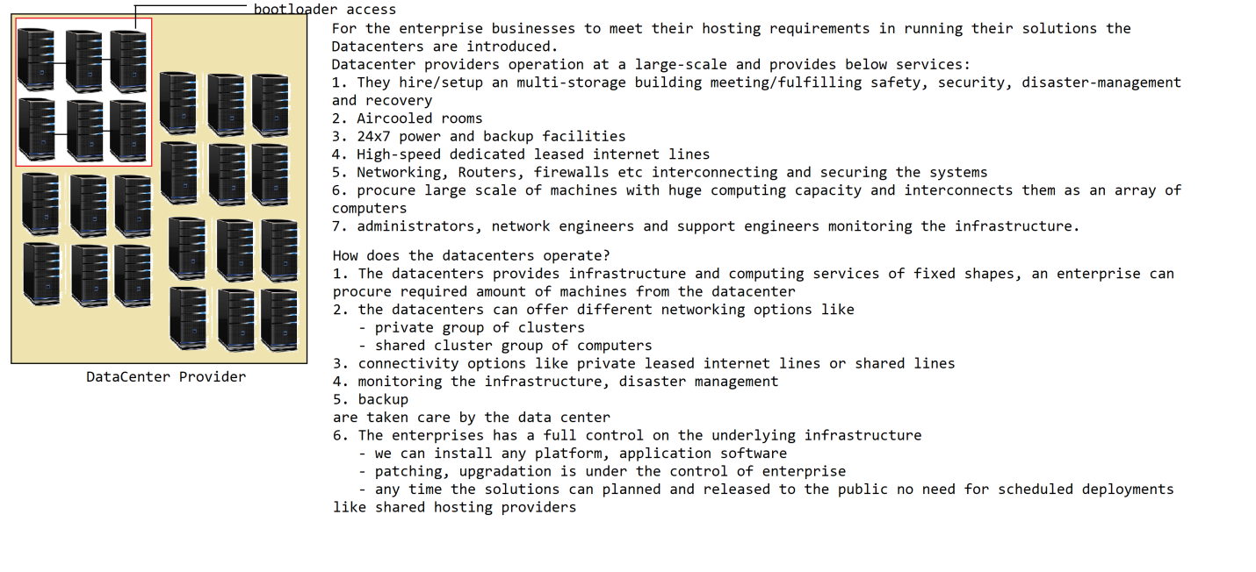Datacenter:

Datacenter setup the multi-storage building in which they procure huge amount of infrastructure and hardware resources required for hosting the applications

advantages:-

1. The cost of investment needed for procuring the infrastructure and dedicated hardware required for running/hosting an enterprise business solutions are less when compared with in-house solution

2. The customers can procure a dedicated machines of required quantity quickly from a datacenter

3. The technical stack over which we want to host our applications are lies in the hands of the customer / business owner itself, since these are dedicated machines allotted to the business owner

4. 24x7 available of the infrastructure is taken care by the datacenter, so guaranteed availability of the business is an added advantage

5. disaster-recovery, fault tolerance and backup/recovery are taken care by the data center

6. highly secured

7. we can procure a cluster of computers on a private network for added security

8. based on-demand of the business we can procure more hardware/machines and scaleout the infrastructure in running the application

9. if the system requirements in running the application has increased, we can procure high-configuration machines by placing an scaleup request to the datacenter

scale-out/scale-in = extending the cluster size or adding a computer to a group of machines is called scale-out. removing a machine from group of computers is called scale-in

scaleup/scaledown = upgrading the physical configuration of a computer like increasing cpu, ram, storage etc is called scaleup and decreasing the machine capacity is called scaledown

dis-advantages:-

1. upon procuring the hardware machines from the datacenter, since these machines doesnt have a platform software or pakcages or libraries installed, the business owner and a team of IT engineers has to setup, configure and bring the systems to the desired state to host the software applications, which might takes a couple weeks around 2-4 depends on the type of softwares we need to install. looks like the business owner invest or pay for nothing to be used out of the infrastructure he procured which is a considerable expenditure incurred

2. the datacenters usually has fixed shape of infrastructure. based on our application requirement we need to choose the closest possible hardware configuration machine, for which we might need to pay additional amount even though we dont utilize the hardware resources

3. There are fixed contractual agreements on the timelines in procuring the infrastructure from the datacenter, for eg.. an minimum of 6 months is required in taking the infra

4. For short-term usage the cost of infrastructure will be quite high. to get better pricing we need to signup long-term contractual agreements in using the infrastructure. ontop of it we need to pay upahead before the usage as per the contract

5. even though datacenters supports scaleout and scalein

- it purely depends on availability and may have to be in waiting queue in procuring the additional infrastructure

- for a scaleup we need to get into an minimal term of contract in using those machines

6. along with the above scaleup/scaledown has their own challenges

Cloud Computing is about on-demand delivery of infrastructure/computing services to world

cloud computing

on demand delivery of computing services to the world is called "cloud computing". As part of the cloud computing there are 3 types of services are provided.

1. IAAS = infrastructure as a service

2. PAAS = platform as a service

3. SAAS = software as a service

#1. IAAS

IAAS stands for infrastructure as a a service. all the computing resources required for hosting/running an software application are provided as part of IAAS. For eg..

1. compute instance (computer) (operating system platform)

2. network resources

2.1 gateways

2.2 firewalls

2.3 subnets

2.4 private networks

3. ip adresses

4. storage (network storage, additional storage backup)

5. load balancers

6. dns resgistries

7. dns services

virtualization technology

virtualization technology is used for creating multiple parallel isolated environments on a physical computer system

If we look at the above IAAS is merely looks like an data center, but there are lot of benefits are there

1. The shape of the machines that can choosen in procuring the infrastructure is flexible we can compose the configuration of the machine with which we want to procure the resources

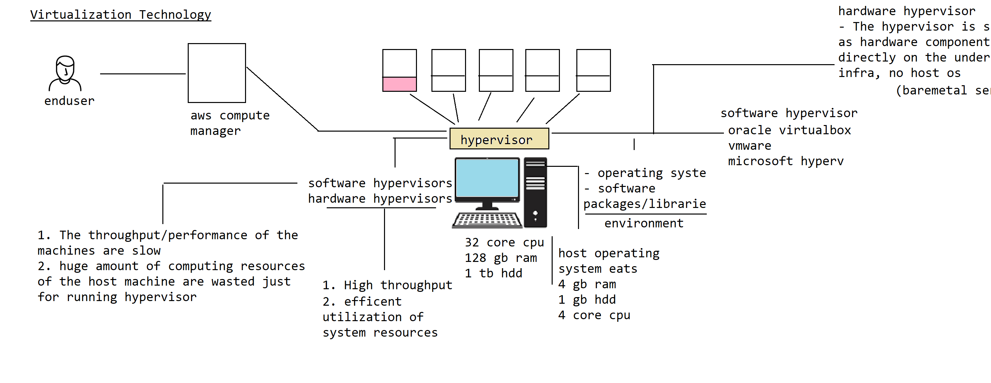Cloud computing

on-demand delivery of computing resources to the world is called "Cloud Computing". As part of the cloud computing there are 3 types of services are provided

1. IAAS

2. PAAS

3. SAAS

#1. IAAS

IAAS Stands for infrastructure as a service. The compute instance and network infrastructure required for hosting the applications are provided aspart of the IAAS.

like

1. Compute instance

2. Network infrastructure

- Routers

- Gatways

- vpn

- subnets

- virtual private networks

- firewalls

3. load balancers

4. dns registries

5. dns service

6. ip address

7. cloud storage

etc

The cloud providers uses virtualization technology in offering IAAS layer flexible to the world.

Virtualization

Virtualization is used for creating multiple parallel isolated environments on a physical computer system. The Virtualization technology works based on hypervisor.

There are 2 types of hypervisors are there

1. software hypervisor = Hypervisor as a software is shipped by the vendors, that has to be installed on the host machine operating system, using which we create virtual machines to share the physical system resources of the machine.

advantages:-

1.1 cost effective solution in creating multiple environments

dis-advantages:-

1.1 throughput or the performance of the virtual machines are low

1.2 computing resources of the physical machine are wasted because of running host operating system

2. hardware hypervisor = The hypervisor is shipped directly as an hardware device which runs on the machine itself without the need of host operating system

advantages:-

1. higher throughput

2. effective utilization of system resources of the host machine

dis-advantages:

1. very costly

The cloud vendors/providers relies on virtualization technology in providing infrastructure to the world.

advantages:-

1. We can procure the computer instance of flexible shape in nature, based on the requirement in running the application, there is zero wastage cost in utilizing the machines as we dont need to signup for high shapes because of restrictions

2. The cloud providers within couple of minutes will be able to provision the infrastructure and make the compute instances available almost instantly

3. The cloud providers works based on pay-per usage model.

based on the usage of cpu/ram and storage and network i/o the enduser has to pay the amount rather than how long the infrastructure has been kept

4. There are absolutely no long-terms contracts required in signing up for the infrastructure. instantly the compute instances are alloted and can be terminated or released immediately, there is no fixed period of usage restrictions are not there

5. scale-out and scale-in of the infrastructure is done instantly, many of the cloud providers offers autoscaling configurations which means we can periodically configure the scale-out and scale-in intervals based on the usage.

6. scale-up and scale-down is supported by the cloud provider

7. periodical backup and restoration in the event of crash is handled by cloud.

The cloud providers takes care of managing the lifecycle of the compute resources

1. provisioning

2. deprovisioning

3. backup

4. restore

5. scale-out/scale-in

6. scale-up/scale-down

Cloud computing

on-demand delivery of computing resources to the external world is called "Cloud Computing". There are 3 different types of services offered by cloud providers

#1. IAAS

#2. PAAS

#3. SAAS

#1. IAAS = stands for infrastructure as a service, all the computing and infrastructure resources required for hosting and running an software application is provided as part of IAAS.

The lifecycle activities like

1. provisioning

2. deprovisioning

3. backup

4. restore

5. scale-out

6. scale-in

7. scale-up

8. scale-down

are taken care by cloud provider

The advantages of cloud over data center or other hosting platforms

1. flexibile shapes

2. no up-front cost/contractual signups or agreement in leasing the infra/compute services

3. pay per usage

#2. PAAS

PAAS stands for platform as a service. For our applications to execute or run on a machine we need the language software or application servers to be available. unless otherwise our applications will not run on the underlying machine.

The softwares that acts as a base/foundation on which the applications softwares run ontop of them are called "platform softwares" for eg..

1. all the language softwares

1.1 java sdk

1.2 python sdk

1.3 php sdk

etc

2. all the application servers or middlewares on which our applications work

1.1 tomcat/weblogic/websphere servers etc

1.2 wsgi/asgi servers

1.3 lamp / xamp server etc

3. database servers like

3.1 mysql server

3.2 postgres sql server

3.3 oracle

etc

unless these softwares are installed/configured on the compute instances, our applications cannot be deployed.

The business organization has to hire a team of system administrators, who takes care of procuring licencse, installing, configuring and managing these platform software

weblogic server -> (cluster)

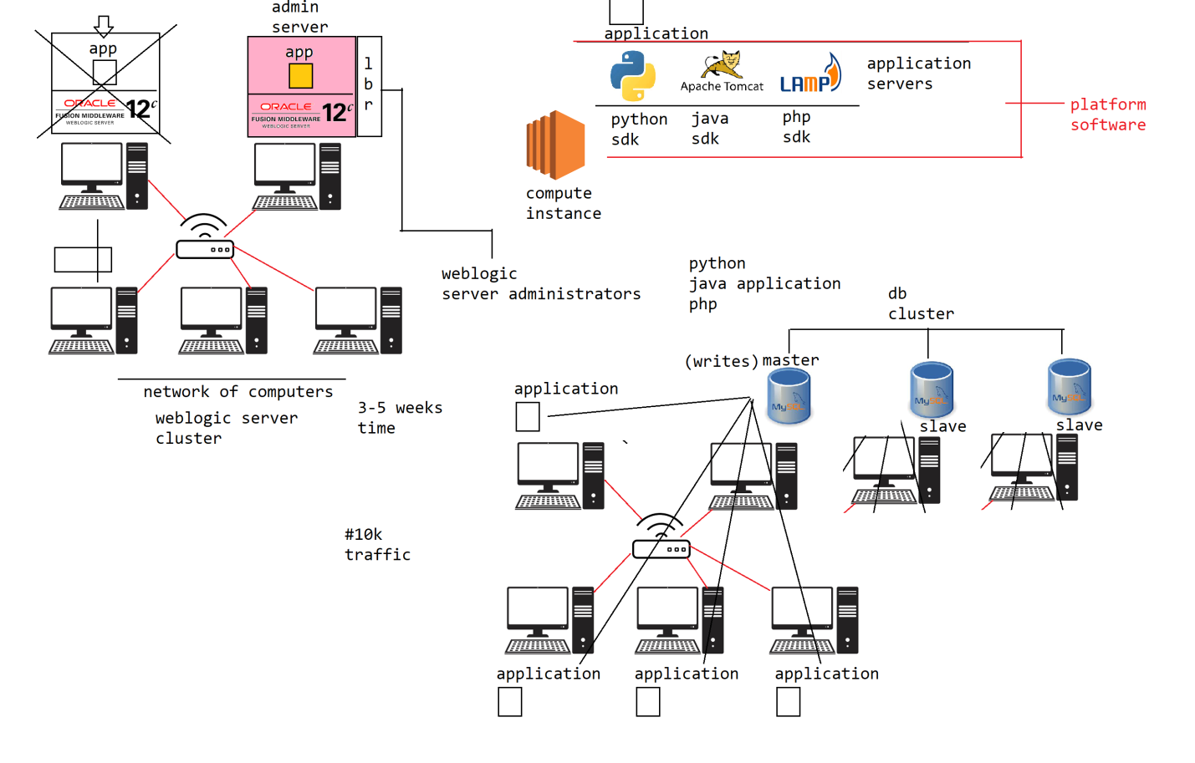

**What is cloud computing, what is the purpose of cloud computing?**

on-demand delivery of computing resources to the world is called "cloud computing", a cloud computing vendor provides 3 types of services.

1. IAAS

2. PAAS

3. SAAS

**#2. PAAS**

PAAS stands for Platform as a Service. For running/deploying an software application on a computing machine along with operating system we need additional software libraries, packages or application server infrastructure.

**For eg..**

**1. a java application** = we need jdk software and application servers to be installed and configured like (tomcat, weblogic or websphere etc) on the machine

**2. a python application =** we need python sdk along with aswi/wsgi servers to be installed

etc

similar for each application of a specific technology we need underlying software packages or libraries or servers to be installed and configured on which our applications works. these libraries/packages/servers on which our application works are called "platform software".

The platform software required for running an application will be different from applicationt to application, the architect/developer of the application needs to determine what platform software is required for running an application

The devops engineer or relevant platform software expert/administrator has to takecare of installing and configuring it, so that we can run our application.

There are lot of problems in manually installing, configuring and managing the platform software.

1. upon procuring/provisioning an cloud compute machine from a cloud provider, to run the software application on the infrastructure, the devops engineer or platform administrator has to manually install and configure the platform software on that machine.

The time required for installing/configuring the platform software is more that delays the delivery of the application and accumulates to the cost of delivery of the application

2. if the platform software has to be configured/installed on a cluster of machines, it would be highly complex and requires lot of expertize in installing and configuring the relevant platform software and many of the times landup in in-appropriate configurations which leads to issues

3. manually managing the platform software installations and configurations is going to be time consuming process when we are rolling on to a large group of applications on a wider scope of machines, so the business owner has to hire a devops automation engineers, will work on writing the programs/scripts for automating the process of installing and configuring these software using tools like

- shellscript - ansible - puppet - chef etc

the cost incurred in automating the platform software setup is going to be very high

4. periodical backup and restoring the platform software has to be taken by the devops/platform administrator team manually which is an tedious job

5. upgradation of the platform software to a newer version has to be taken care by the devops / platfrom administration team. an excessive care and proper strategy has to be choosen for software upgradation. an sandbox environment has to be setup in testing the existing application and identifying the fine tune configurations required in running the application on new versions of the platform

it is quite risky and time consuming job in upgrading the underlying platform software and inccurs huge amount of cost in upgrading the platform.

and eventually may require some sort of automation to be inplace in upgrading the platform software to expedite the process.

6. uptaking the patches and monitoring the systems to ensure their stability is a tough job

7. procuring the necessary software licenses and ensuring there are properly used need to be taken care

8. The scale-out and scale-in of the underlying machines will be taken care by the cloud provider, but scaling-out and scale-in of the platform software has to be manually managed by the devops/platform administrator which is a tough job

9. the scale-up and scale-down lifecycle activities on the platform software has to be taken care by the devops/platform administrator

Even though the cloud providers are providing the IAAS services (infrastructure/computing resources) to the users, managing the platform softwares and ensure to work on lifecycle activities are quite difficult.

**To overcome the above challenges, the cloud providers supports PAAS.**

**provision**: a computer 4gb ram, 2 core cpu, 500 gb hdd

**provision**: a weblogic server computer, 8gb ram, 4 core cpu, 1 tb hdd (not compatible)

-> 2 node cluster instance for HA

-> Loadbalancer

-> Backup policy and restoration

-> upgradation/patches (schedule upgrades/autoupgrades)

-> create

10/20 minutes ->

#1 scale-out - 2 more instances of weblogic server

PAAS stands for platform as a service. all the required software packages, libraries and application server infrastructure which acts as a platform in running the enduser applications are managed by the cloud provider itself.

There are lot of advantages of using PAAS from a cloud provider

1. The provisioning of the infrastructure along with PAAS layer ontop of it will be taken care by the cloud provider, so that we can get the machines with PAAS installed and pre-configured and ready for deploying our applications

2. Upgrading and patching the PAAS layer is taken care by the cloud provider, so that we dont need apply or upgrade the PAAS infrastructure

3. periodical backup and restoration (incase of crash) of PAAS software along with infra is taken care by the cloud provider

4. The lifecycle operations like scale-out/scale-in , scaleup and scale-down are taken care by the cloud provider in managing the PAAS software

**#3. SAAS**

SAAS stands for Software as a Service.

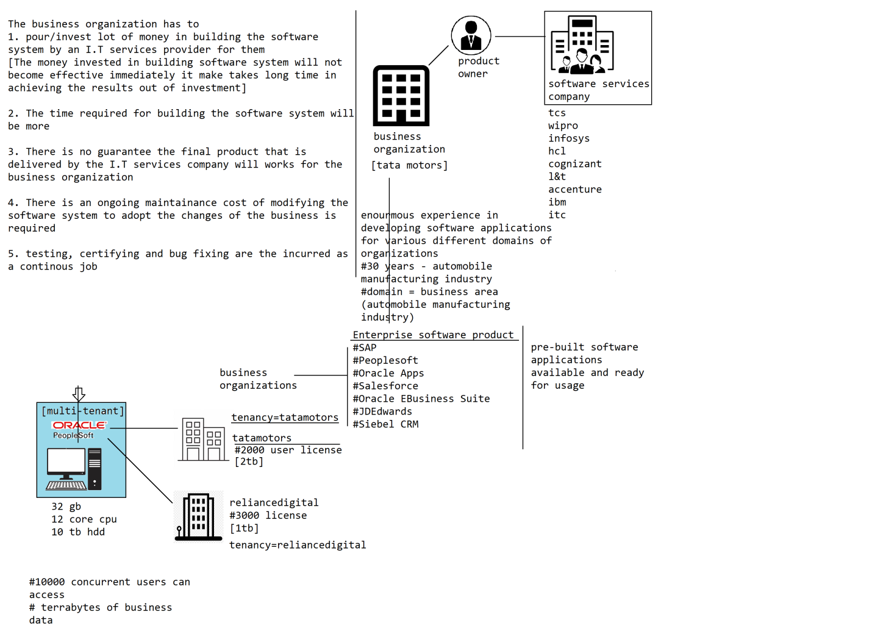

How does the business organizations has to use these Enterprise Software Applications that are pre-built and are ready for usage?

For eg..

1. SAP

2. Oracle EBusiness Suite

3. JDEdwards

4. Peoplesoft

5. Salesforce

6. Sibel CRM

7. Microsoft Dynamics

8. Taleo

9. Oracle Apps

#1. The business organization has to procure the license for the Enterprise Software System and respective module licenses based on their usage

- The cost of procuring the lincense in using these Software products are pretty much high

#2. These systems requires huge computing capacity and storage in running on the machines. So the business organization has to procure groups of server grade computers for installing and running these software products

- The cost of infrastructure in running these software products are quite high

#3. Installing and configuring these enterprise software systems are quite complex, and requires special engineers who are called administrators of the software product to be hired for installing/configuring the product

#4. we need experts of the product, takes care of customizing and adopting the product for our business organization and the processes

#5. We need a support team or an administration team who will monitor continously and perform regular maintainance activities required for ensuring the smooth running of the software system like

- backup

- restore

- cleanup activities etc

From the above we can understand adopting and using these enterprise software products is a quite tedious job and required huge investment/maintainance cost incurred in running these systems.

A moderate business organizations cannot afford in using these enterprise software products

To overcome all the above dis-advantages in using a software product by the endusers the SAAS has been introduced by the cloud providers

There are lot of popular enterprise software products popularly used by many of the organizations in the world, so such software products are identified by the cloud provider and provisioned and provided them to the organizations

**SAAS**

Software as a Service, where the cloud provider provides the Enterprise Software products to the world in a multi-tenant model.

1. The cloud provider takes care of provisioning, installations and configuration of the enterprise software product

2. since it is an multi-tenant installation, the cost of infrastructure and licenses of the software is distribtued/shared to multiple customers/endusers

3. monitoring and maintainance activities like backup/restore are taken care by the cloud provider

4. all the lifecycle activities like

- scaleup/scaledown

- scale-out/scale-in

are handled by the cloud provider

There are lot of cloud providers are there in the market

1. Amazon Web Services cloud (AWS)

# IAAS

# PAAS and SAAS support

2. Google Cloud Provider (GCP)

#technology innovation #IAAS

3. Microsoft Azure 4. Oracle Cloud Infrastructure (OCI) #strong

#technology companies

- Platform Software products

- Enterprise Software products

etc

**The cloud providers offer 3 types of services**

1. IAAS

2. PAAS

3. SAAS

every cloud vendor/provider doesnt provide all the 3 services, depends on the cloud provider and their footprint in those areas they provide different types of services.

different cloud providers provides different array of services, we need to choose the cloud provider carefully based on the product requirements we wanted to host on the cloud platform

--------------------------------------------------------------------------------------------

**AWS Cloud**

AWS Cloud stands for amazon webservices cloud provider offers the 3 types of cloud services to the world

1. IAAS

2. PAAS

3. SAAS

AWS Cloud provider offers free-tier account for 1 year. dont go by the world free-trail means everything is free.

There are few services categorized to free-tier and have their usage limits as well.

For eg..

an AWS Compute instance is free for 720 hours only (per month) - 1 year

similarly for all the types of services there is a usage limit we should read the billing and pricing details before using the aws services.

To start with aws cloud we need to create an aws free-tier account. while creating an aws free-tier account you need a debit/credit card handy, so that aws authenticates your card but deducting $1 or 2 INR to open your account.

There are 2 types of accounts are there in aws cloud

1. AWS ROOT account

ROOT Account is the owner of the aws account who has complete/un-restricted access to all the services of the aws account.

note:- make sure you keep the account credentials highly secured and dont disclose to anyone, giving the credentails of your aws account to other users is equal to providing access to your bank account directly

AWS Root account is the user who can keep track of all the services/resources that are created under the aws account. he can control or grant access to the aws account by creating additional users called IAM Users

**2. IAM User account**

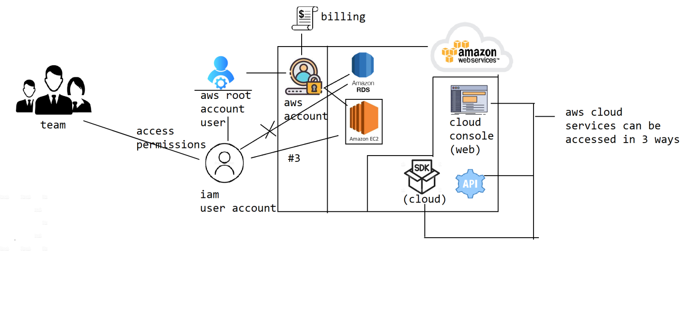

To use the services of the aws cloud platform, we need to create an aws account. An aws account is the one through which aws keep tracks of the services and resources being created by an user within the aws cloud infrastructure.

Which resources are created or entitled for which account and who can access, administor and manage the resources are driven through aws cloud account.

There are 2 types of users are there in aws cloud

#1. Root account user

#2. IAM user

**#1. Root account user**

The Root account user will be created aspart of the aws cloud account creation/sigup/registration process itself. The root account user has unrestricted access to all the services of the aws cloud platform.

The root user can delegate access to the aws services/resource of his account and grant permissions to the resources to other users of his account.

**#2. IAM user**

An aws root user can delegate access to the services/resources by creating additional users in his account who are called "IAM user"

The aws offers free-tier account upon signup for an aws account. but not all the services are free and there is an usage limit on each service.

--------------------------------------------------------------------------------------------

**AWS domains**

-------------

There are lot of cloud services offered by the aws cloud platform, identifying the services and using them becomes messy or difficult. To easily help us in locating, navigating and identifying the AWS Cloud services, aws has grouped the services into domains.

A domain is nothing but group of related services of similar nature so that users can quickly browse them at one place

The AWS has categorized its services into 7 domains

1. Compute

2. Network

3. Storage

4. Database

5. Security

6. Management Tools

7. Messaging

--------------------------------------------------------------------------------------------

**How can we access and use the services/resources offered by the aws cloud platform?**

To access the aws cloud platform services we need aws cloud account and we need users of the account to access the services.

The aws allow us to use the cloud services in 3 ways.

**#1. aws cloud management console**

aws cloud management console is an web application exposed/provided by the aws cloud platform through which we can browse the service offerings of the aws cloud platform. we can perform all the lifecycle operations on the cloud services through aws cloud console application.

The Cloud developers, administrators or cloud engineers uses the aws cloud console to easily navigate and use the services of the aws cloud account.

**#2. programmatic access**

The aws cloud platform has provided cloud sdk/api (support different languages), so that the developers can use these apis in using, managing and administering the cloud resources of the aws

**#3. REST api access**

The aws cloud platform has exposed REST Endpoints through which we can browse, administer and manage the cloud services

#2, #3 are for programmers not for cloud engineers.

AWS has provided an tool called AWS CLI (Command-Line interface)

AWS Cloud Shell -> aws cli commands

**How does aws cloud allows us to access the cloud platform services?**

There are 3 ways aws allows us to access the cloud services

#1. aws cloud console

#2. programmatic access using aws cloud sdk

#3. REST Endpoint / HTTP API Access

#2 programmatic cloud sdk, #3 REST Endpoint access will be used by the cloud developers and tool provider, using which they automate the process of cloud services/resources.

For eg.. there are IAAC tools like terraform, cloud formation uses the API access in automating the process of lifecycle management on the cloud resources.

On top of the above the aws has provided a quick and handy tool/utility called AWS CLI, it is an command-line interface which can be installed and configured to our aws account. Using the AWS CLI a cloud engineer/administrator can quickly manage the cloud resources of his account instead of logging in through cloud console

--------------------------------------------------------------------------------------------

**AWS Architecture**

The AWS Architecture refers to how does the aws cloud platform has been organized and designed to spread/provide cloud services to the world

**#1. AWS Regions**

----------------

AWS Region is nothing but a geographical location where it offered the cloud platform services from a specific location. A Region is not an country rather they can be multiple regions within a country from where AWS cloud offers the services.

For eg..

United States, AWS has 4 regions

US-EAST-1

US-EAST-2

US-WEST-1

US-WEST-2

AWS has spread across 22 regions around the world from where there are operating from. upon logging into the cloud console, on top right corner we need to choose the region from where we wanted to manage or use the cloud resources/services from.

How do we choose a region to utilize the cloud resources/services of the aws cloud platform?

There are 2 factors based on which we should choose the region

**1. network latency**

Based on the targeted audience/customers of our business we should choose a aws region closest to them. if we choose a region far away from the location from where you are offering business services, then the customer would find delay in accessing your application due to latency in transferring the request from customer location to the region where our application is hosted

For eg.. if our targeted audience are from India, and if we host our application in us-east-2 (ohio), then it takes lot of time for sending the request all the way down to the united states and getting a response, where enduser see a delay in loading the web pages/accessing the application which would spoil the end-user experience

**2. pricing**

different aws cloud regions offers different pricing for the cloud resources, these pricing is varied depends on local government policies and demand of services at that location.

The aws might offer services with different price across different regions to evenly distributed the people across the regions of a location

**#2. Availability Zones (AZ)**

----------------------------

Within a AWS Region, AWS has setup multiple Availability zones. An Avaiablablity Zone is nothing but a group of datacenters within a location from where AWS is offering cloud platform services from that location.

Within a AWS Region, there can be multiple Availability zones, and AWS ensure/promises to have atleast 2 Availablity Zones within an AWS Region.

AP-SOUTH-1 (Mumbai)

-> AZ-1 = loss/poweroutage within state (standstill)

-> AZ-2

**AWS Architecture**

AWS Architecture refers to how does aws cloud platform has spread across and provides the cloud services to the world.

**#1. AWS Region**

AWS Region is a geographical location from where AWS cloud platform is providing its services across. There are total 22 regions over which AWS Cloud platform has spread across. AWS Region is not an country rather a place where it is located within the a country from where it is operating in providing the services. A country can have more than one regions as well.

There are 2 factors based on which we should choose a region in using the cloud services.

1. network latency

2. pricing

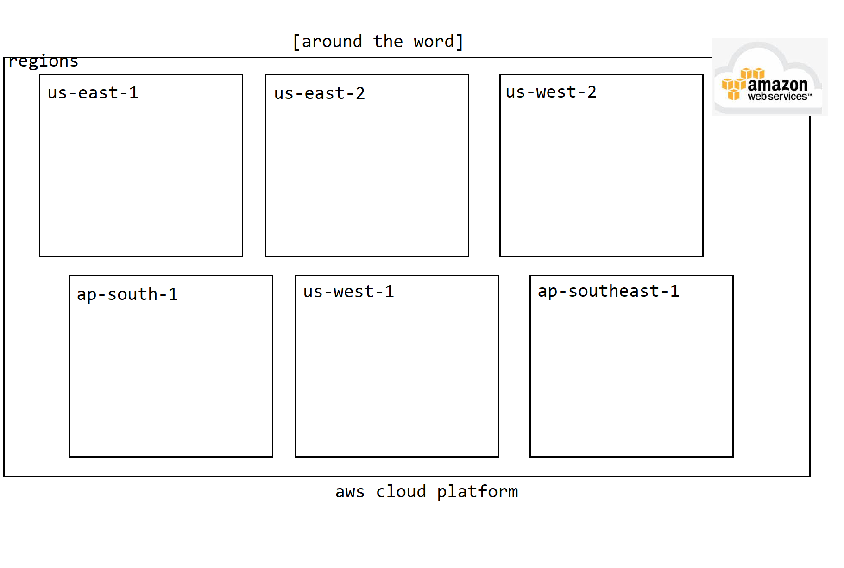

**#2. Availability zone**

Availability zone is a group of datacenters within a region from where aws cloud platform is offering the cloud services. In each AWS Region atleast 2 availability zones are setup by the AWS Cloud platform for ensuring High Availablity

The availability zones are meant for high availability of the services/resources within a region. The AWS recommends us to host our applications across he AZ of the region, so that if one Availablity Zone fails/crashes there is guarantee that your application still exists and can serve the customer from the other AZ of the region.

The purpose of AZ is for achieving the High Availablity

AWS Cloud platform chooses the availability zones within a region, by carefullying evaluating various different parameters like

1. Climatic conditions

2. Power availablity

3. Cyclone conditions

4. Tornados etc

So that the likeliness of all the availablity zones within a region going down is very less.

These Availablity zones are inter-connected with dedicated high-speed internet lines to ensure there is zero no network latency across the AZ within the region.

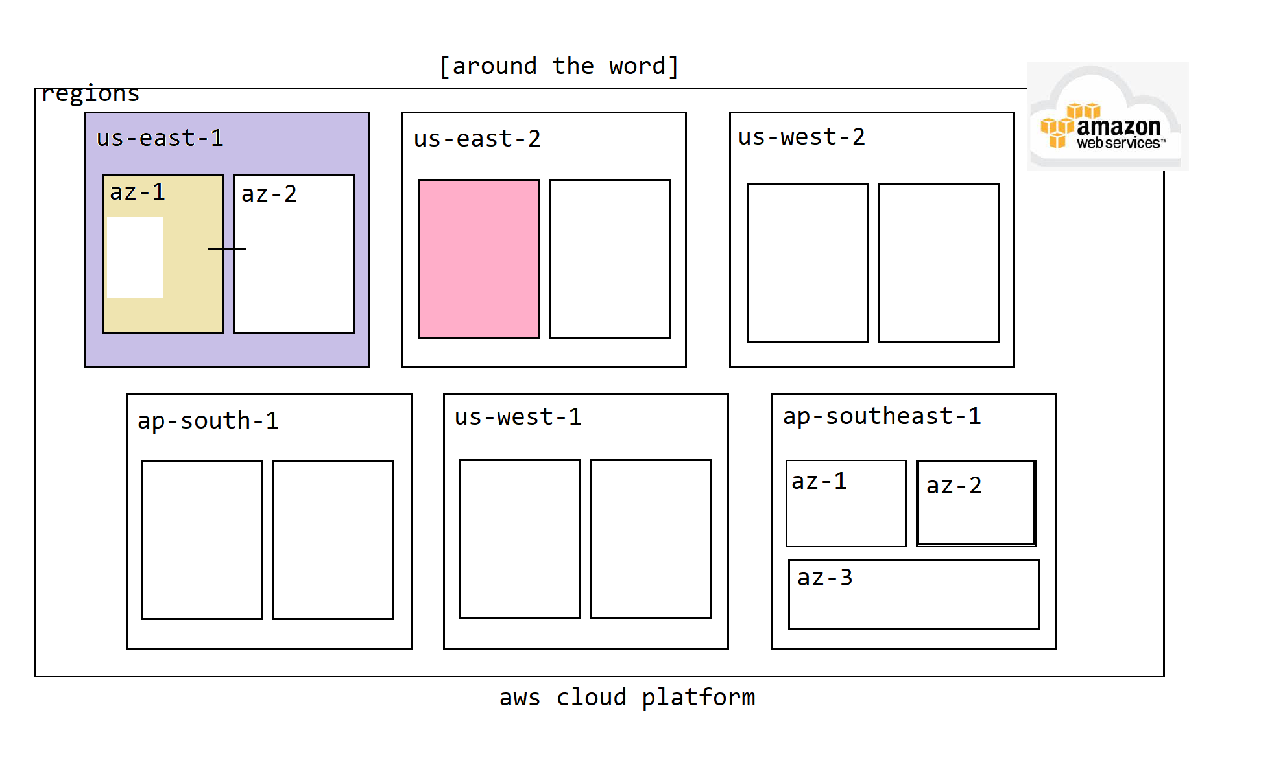

**#3. Edge Locations**

Edge locations are the mini datacenters co-located across the regions of a aws cloud platform. There are few shared/global services are there within AWS Cloud platform like

1. Cloud Front

2. Route53

etc

to reduce the network latency in distributing these services to the customers, aws has setup mini datacenters from where they operate these shared/global services

These edge locations are replicated centers across the regions in offering the global services with low latency.

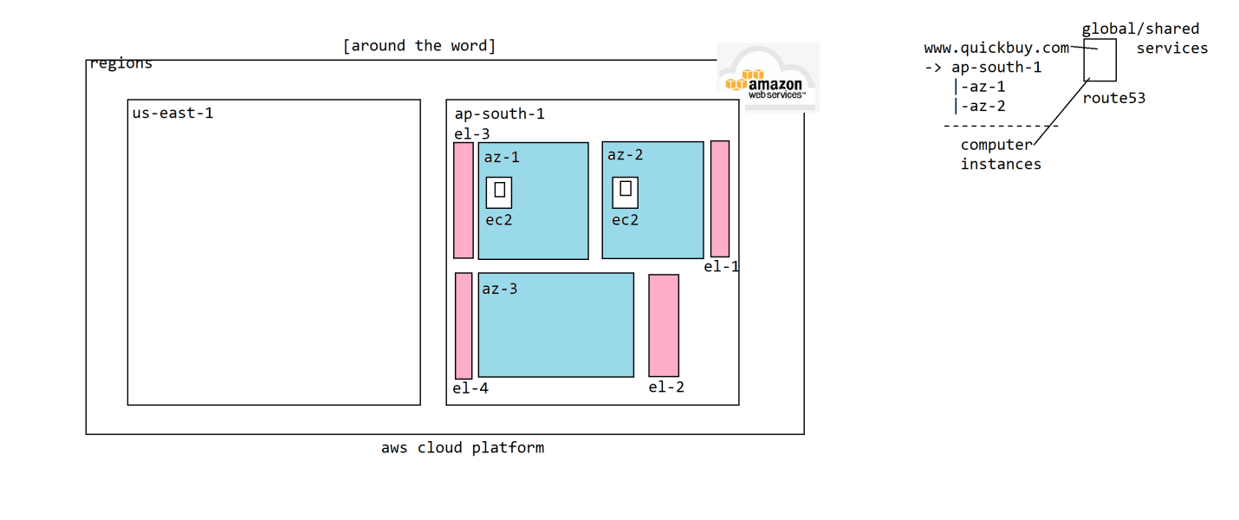

**Edge locations**

edge locations are the co-located locations within an aws region, which are a kind of mini/small datacenters. In these edge locations amazon hosts global/shared services to reduce latency in offerring them

1. cloud front

2. route53

**Scope of AWS Services**

There are various different cloud services offered by the aws cloud platform, these services can be categorized into 3 different scopes based on their availablity/accessibility

The scope of services means, those are created and bounded to which scope within the cloud platform so that cloud engineers can access and manage these resources/services created.

1. Global

2. Regional

3. Availability Zone

**#1. Global scope**

The services categorized to the global scope are accessible and available across all the regions of the aws cloud platform. A change in these services will effect all the regions of the aws account.

For eg.. let us explore few global services to understand

**1.1 Amazon Route53**

If we publish an dns entry into Route53 service, the change would be applied and propagated across all the regions of the aws infrastructure for that account

**1.2 IAM registry**

The AWS accounts are created and changes applied to the aws account users are propagated and applied globally at the account level

**1.3 AWS Cloud Front**

AWS Cloud Front is an cdn (content delivery network) server, into which we can propagate an static content like js, css, images etc and these resources would be propagated across all the regions of the aws infrastructure automatically

**#2. Regional scope**

These services are created within a region and are accessible/visible within the region only

**2.1 DynamoDB**

it is an nosql database which is an region based service, upon creating the aws cloud platform partitions the dynamodb table and replicates across the availability zones of the region for HA

**2.2 S3 bucket**

The objects stored within an S3 bucket are scoped to the region level

2.3 Elastic Load Balancer

2.4 Virtual Private Cloud Network

**#3. Availability Zone scope**

These services are scoped to the Availability zone in which those are created and can be visible and managed only within the zone

**3.1 Amazon Elastic Block Storage**

EBS volume is an harddisk drive for an ec2 instance and is scoped to the ZA location only, we can attach an EBS volume to the ec2 instances of the same AZ only

3.2 Amazon EC2

3.3 Subnet

**#Architecture of AWS**

1. AWS Region

2. Availability Zone

3. Edge Locations

4. Scope of Services

**The AWS Cloud services can be categories into 8 core domains**

1. Compute domain

2. Network domain

3. Storage domain

4. Database domain

5. Security domain

6. Management Tools

7. Messaging

8. Developer Tools

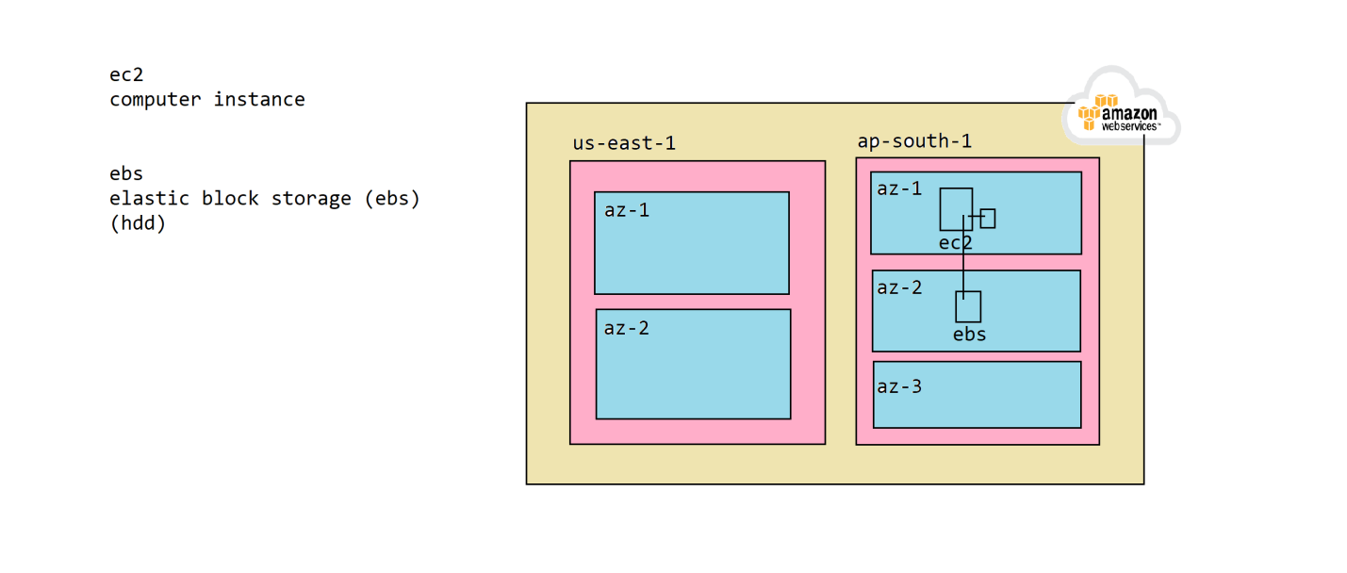

**AWS Service scope**

AWS Service scopes refers to the a resource or service of a AWS is entitled for which level and the manageability aspect of the service. There are 3 scopes are there in aws cloud platform.

1. global

2. regional

3. availability zone

**1. global scope**

the service is created and accessible across all the regions of the cloud infrastructure platform.

- Route53

- AWS Cloud Front

- IAM registry

**2. Regional scope**

The service is created to the region level and is accesible and manageable within the region.

- DynamoDB

- Elastic LoadBalancer

- S3 Bucket

- Virtual Private Cloud Network

**3. Availabiblity Zone**

These services are created per AZ

- Elastic Block Storage

- EC2 instance

- Subnet

--------------------------------------------------------------------------------------------

#network domain

#compute domain

ec2 instance

ec2 stands for elastic cloud compute, which is nothing but an machine/computer created on the aws cloud platform

#provisoning = The process of creating an resource on a cloud platform is called provisioning.

**How to launch an ec2 instance on aws cloud platform?**

#1. goto services choose compute and navigate into ec2

#2. click on launch instance

#3. we need to provide the details in creating the ec2 instance

3.1 provide name for the instance (for eg.. javainstance)

3.2 choose the AMI (amazon machine image) (operating system)

- ubuntu family

- 22.04 LTS (free tier)

3.3 choose the shape of the instance (t2.micro only)

3.4 click on create keypair

This generates an ssh keypair in accessing the ec2 instance

3.4.1 enter the keypair name

3.4.2 choose the algorithm (default: RSA)

3.4.3 choose type of keypair (default: pem)

The pem file will be downloaded upon clicking on finish, place the ".pem" into $USER_HOME/.ssh directory

upon creating the keypair choose the keypair name from the drop down which which we want to create the instance

3.5 choose the default vpc, subnet and enable public ip address (everything is auto-selected, just cross-check and leave it to the default)

3.6 scroll-down and click on launch

goto ec2->instances page and identify the instance we provisioned and copy the public ip address of the instance and use it for ssh into the computer

**How to connect to ec2 instance?**

1. install gitbash on your machine

2. open gitbash

3. enter ssh command for connecting to the ec2 instance using public_ip and pem file as below.

ssh -i ~/.ssh/javainstancekp.pem ubuntu@publicip

What is SSH, why do we use it?

SSH stands for Secure Shell protocol. SSH is used for accessing the remote linux computers over the network securely.

How to connect to the remote linux machine over ssh?

1. we need to install gitbash tool on our machine

2. run ssh command for connecting to the remote computer

ssh -i pathKeyFile username@publicip

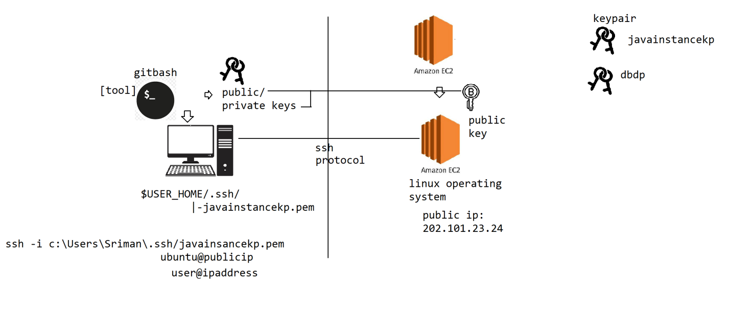

--------------------------------------------------------------------------------------------

**#Network domain**

The network domain provides various types of network resources like routers, firewalls and gateways etc that are required for hosting, interconnecting and enforce security or traffic restrictions on the resources with aws infrastructure

**#1. Virtual Private Cloud (vpc) Network**

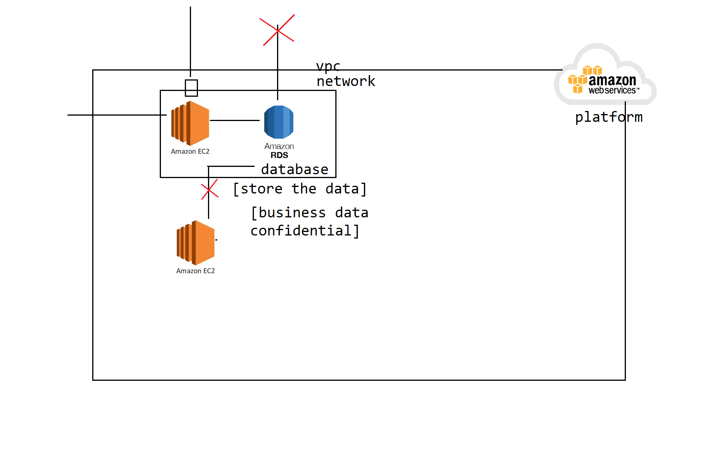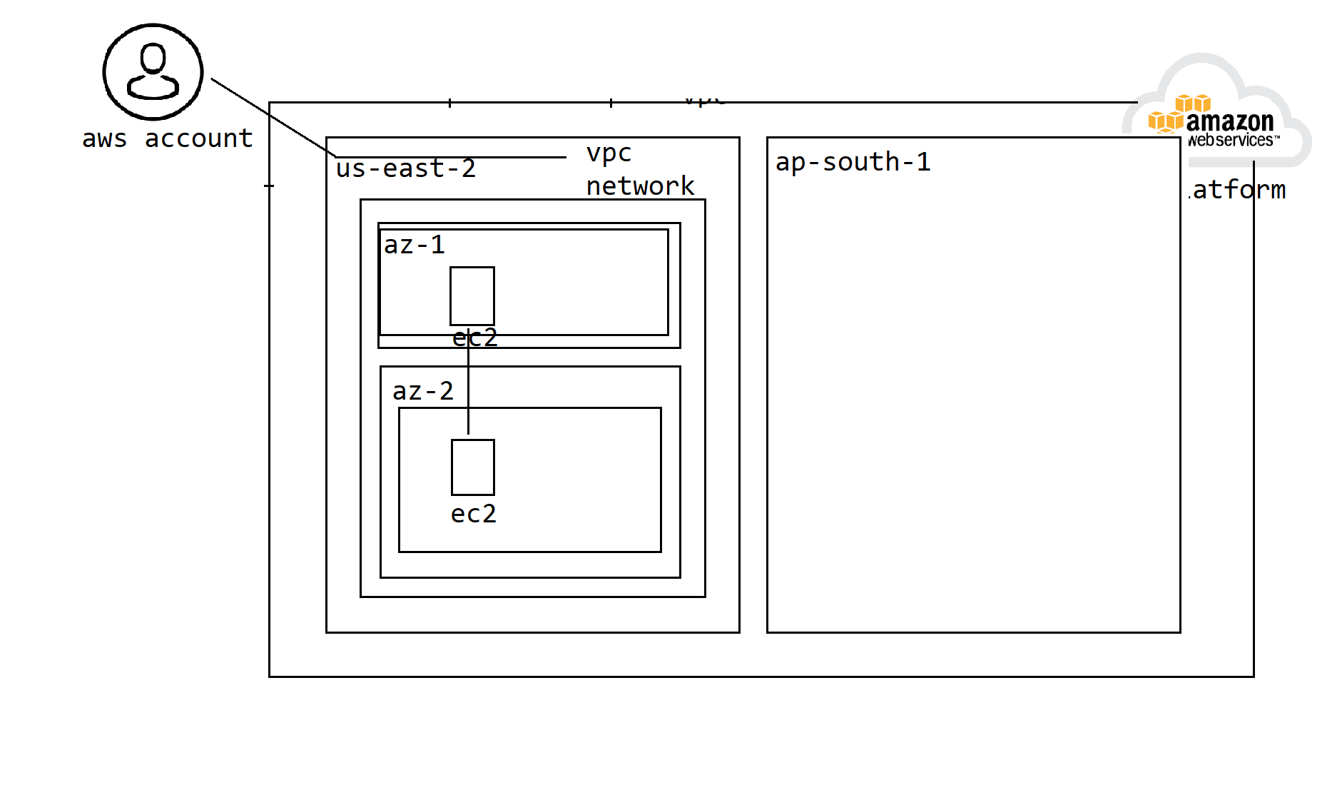

vpc network stands for virtual private cloud network, it is an isolated network of resources of an aws account user.

An aws account user can create an vpc network, he can provision resources within the network keeping them isolated from other resources of the aws cloud platform. The resources of one vpc are completely isolated from the resources of another vpc

vpc are created at the user account level per region of the user

**#1. Virtual Private Cloud Network (VPC Network)**

VPC is an isolated network of resources of an aws account user, all the resources within an vpc are isolated from other resources of another vpc by default.

1. A vpc is created per user account, per region, where all the availability zones of the region are part of the vpc

2. by default all the resources within the vpc can communicate with each other

3. per aws user account, per region we can create at max 5 vpcs only (soft limit)

4. by default a resource in one vpc cannot communicate with another resource of other vpc, even though both vpcs belongs to same aws useraccount of same region, if we want resources across the vpcs to communicate with each other we need to enable vpc peering

5. by default per each user account, across all the regions aws will configure one default vpc

In aws cloud platform there are 2 types of limits are there

1. **softlimit** = something by default enforced by the aws cloud platform for each type of service (if required) and can be extended upon request

2. **hardlimit** = the hardlimits cannot be extended or modified.

**What is the purpose of a vpc?**

There are many ways vpc is used for organizing and managing the resources of an organization

**#1. business unit/department**

In an organization there can be multiple business units or departments, across the business units or departments we want to deploy and host the applications specific to the department. How to ensure the applications of various different departments are deployed and kept isolated from one another. How to enforce a different security restrictions on different resources of various different departments.

That is where we can keep them separately as part of 2 different vpcs

**#2. across the projects**

we can create separate vpcs per each project and can isolate the resources of one project from another one using vpcs

**#3. per environment**

we can create different vpcs each per environment like

devvpc

testvpc

prodvpc

etc

How to create an vpc?

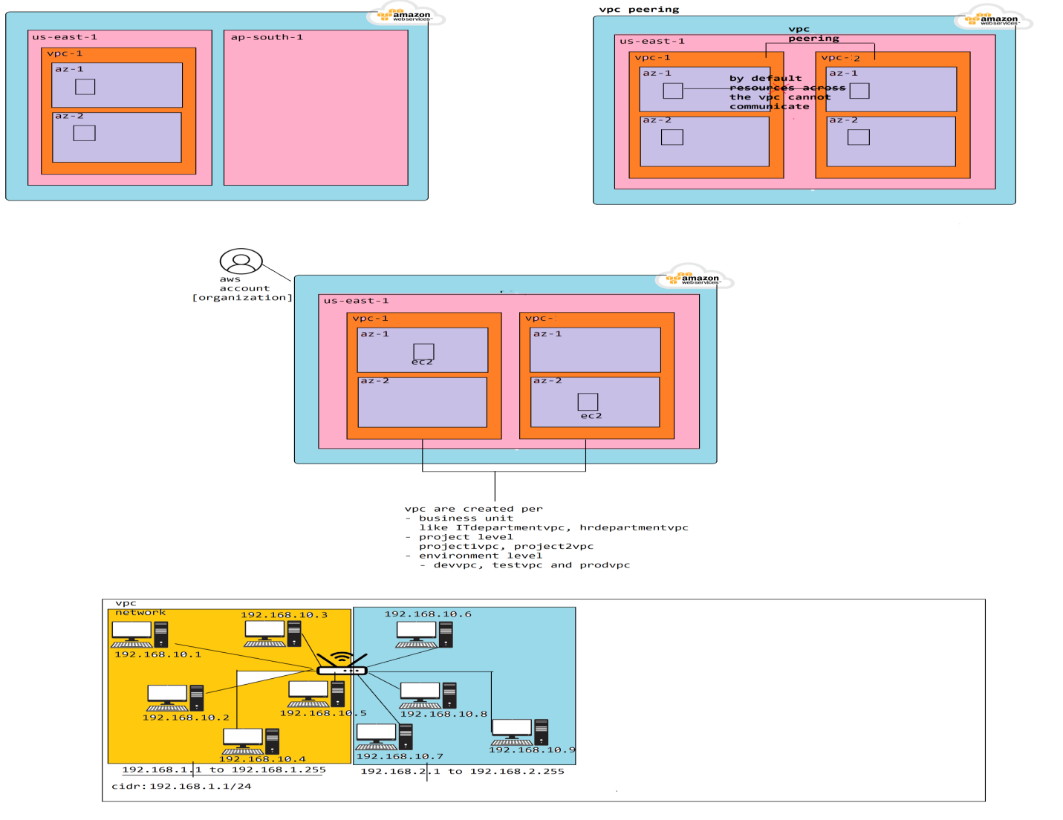

**#1. virtual private cloud (vpc) network**

vpc is an isolated network of resources of an aws account user within the region.

1. an aws account user can create at max 5 vpc per region within his account (softlimit)

2. the resources within a vpc by default can talk to only the other resources within the same vpc

3. an vpc spans/spreads across all the availability zones of a region

4. by default the resources can talk to only the other resources of the same vpc,if we wanted the resources to talk to other resources of an different vpc of the aws account users then we need to enable vpc peering

5. per each region of an aws account an default vpc is created by the aws.

**purpose of vpc:**

vpc is being used in many ways for organizing and controlling the access to the resources at various different purposes

1. across the business units/departments of an organization to isolate the resources of them we can create separate vpcs

2. across the different projects

3. for different environments like dev, test, prod etc

**How to create an vpc?**

To create a virtual private network to isolate the resources from the others we have provide the CIDR range along with name of the vpc.

CIDR stands for class-less inter-domain routing, used for specifying the network and host address range in creating ip address for the resources.

**#2. subnet**

vpc is an isolated big network which spans across all the availability zones of a region in which it has created. by default all the resources created within the vpc are accessible to each other and the same traffic restrictions are applied to all the resources.

But for different group of resources we wanted to apply different security restrictions and accessibility, for eg.. we wanted the rds (database) instance to be private and accessible to the resources within the vpc, but we wanted the ec2 instance to be accessible publicly by anyone, this can be dont be separating and them into 2 subnet works of an vpc

a vpc can be further broken down into smaller networks where we can create resources within the subnet of a vpc based on the restrictions we wanted to enforce.

1. A subnet is created within the availability zone of a vpc

2. per vpc we can create at max 200 subnet

3. it is recommended to create minimum 2 subnets across the availability zone of an vpc.

**What is the purpose of a subnet?**

There are 2 reaons why we use subnet

1. to enforce different security/traffic restrictions to various different group of resources within a vpc we can distribute them into separate subnets

2. to distribute the resources across the availability zones of a region

**How to create a subnet?**

while creating a subnet we need to specify

1. the vpc in which we wanted the subnet to be created

2. availability zone in which want to create

3. subnet name

4. cidr notation within the vpc range

**There are 3 types of subnets are there**

1. private subnet

2. public subnet

3. hybrid subnet

**#1. private subnet**

by default when we create a subnet within the availability zone of a vpc it acts as an private subnet only, which means all the resources within the subnet can talk to any other resources across all the subnets of the same vpc. These resources are not acessibile publicly to the outside world

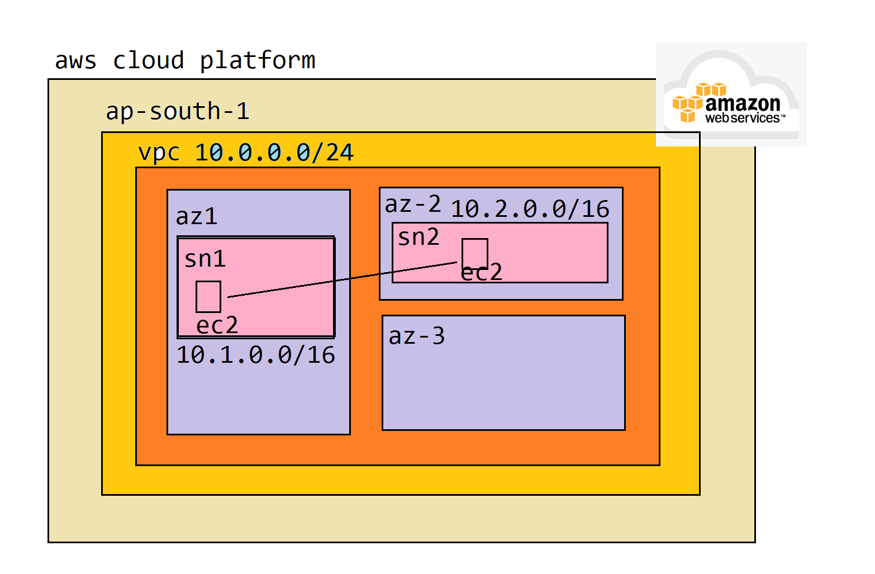

**vpc network**

vpc network is an isolated network of resources of an aws user account within a region

**subnet**

vpc is a very big network that scopes to the region level, there are various resources we wanted to create for an application, the access registrictions and security rules we want to apply for these resources are different from one to the another, if we place all of these resources under onesingle network, then we cannot control/restrict the resources differently

The subnet is nothing but a smaller network within the vpc in which we can create resources and manage the security restrictions on them

1. per vpc it is allowed to create at max 200 subnets

2. subnet is scoped to the availability zone level

3. it is recommended to create atleast 2 subnets across the availability zones within a vpc for high availability, so that we can distribute the resources across the AZ

**There are 2 reasons for creating a subnet**

1. to apply different traffic restrictions to the group of resources within the subnet

2. the way we can bind resources to a specific availability zone of a region within the vpc is through subnet

within the region max #200 subnets are allowed, we can create any number of subnets within an AZ, based on group of resources and restrictions we want to apply. but cummulative no of subnets should not exceed #200 within that vpc

**There are 3 types of subnets are there in aws cloud platform**

1. private subnet

2. public subnet

3. hybrid subnet

**#1. private subnet**

by default when we create a subnet within the availability zone of a vpc within a region, the subnet becomes private subnet only, which means the resources within the private subnet cannot be accessible from external network.

only the resources within the vpc across the subnets can communicate with each other

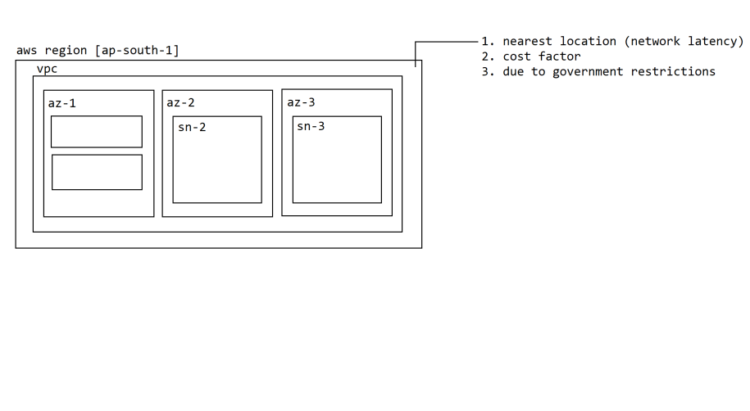

**subnet**

subnet is a sub-network out of an vpc network to enforce traffic/security restrictions on a group of resources

1. subnets are scoped to the availability zone

2. at max we can create 200 subnets within an vpc

3. it is recommended to create atleast 2 subnets across the availability zones of an vpc to distribute the resources

There are 2 main reasons for using an subnet

1. to distribute resources across the availability zones of an vpc in an region

2. to enforce traffic restrictions/security on different groups of resources

we might need to create multiple subnets within the availability zone for enforcing different security restrictions on different group of resources

There are 3 types of subnets are there

1. private subnet

2. public subnet

3. hybrid subnet

**#1. private subnet**

by default when we create a subnet within the availability zone of a vpc within a region, the subnet becomes private subnet only, which means the resources within the private subnet cannot be accessible from external network.

only the resources within the vpc across the subnets can communicate with each other

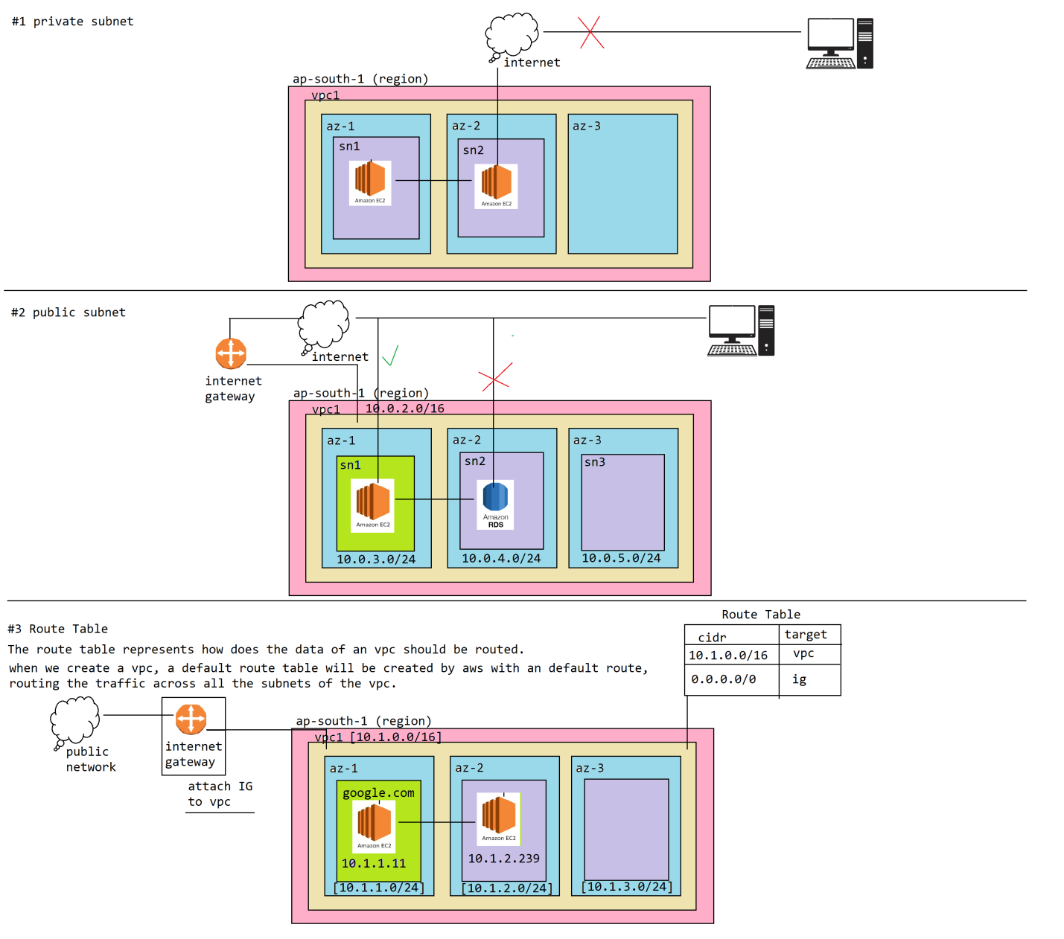

**How many types of subnets are there?**

There are 3 types of subnets are there

1. private subnet

2. public subnet

3. hybrid subnet

**#1. private subnet**

by default when we create a subnet within the vpc it becomes private subnet, all the resources within the private subnet cannot be accessed from the external world or the resources within the private subnet cannot access the traffic on the external world

inbound/outbound external network is not available

all the resources across the subnets of the vpc can communicate with each other

**#2. public subnet**

The resources within the public subnet will have both inbound/outbound to the external network.

To make an subnet as an public subnet we need to attach an internet gateway

**#3. Internet Gateway**

Internet Gateway is a aws network device which is attached to public internet. To make an subnet as a public subnet, we need to create an internet gateway (IG) and attach to the vpc of our network

we can use the internet gateway to route the traffic from the subnets of our vpc to the external network, by attaching the IG to the VPC.

Note: when we attach an IG to the vpc, the subnets of our vpc will not become public subnets, to make a subnet public subnet we need to configure routing rule

**#4. RouteTable (RT)**

By default when we create an vpc, a default route table will be created by the aws.

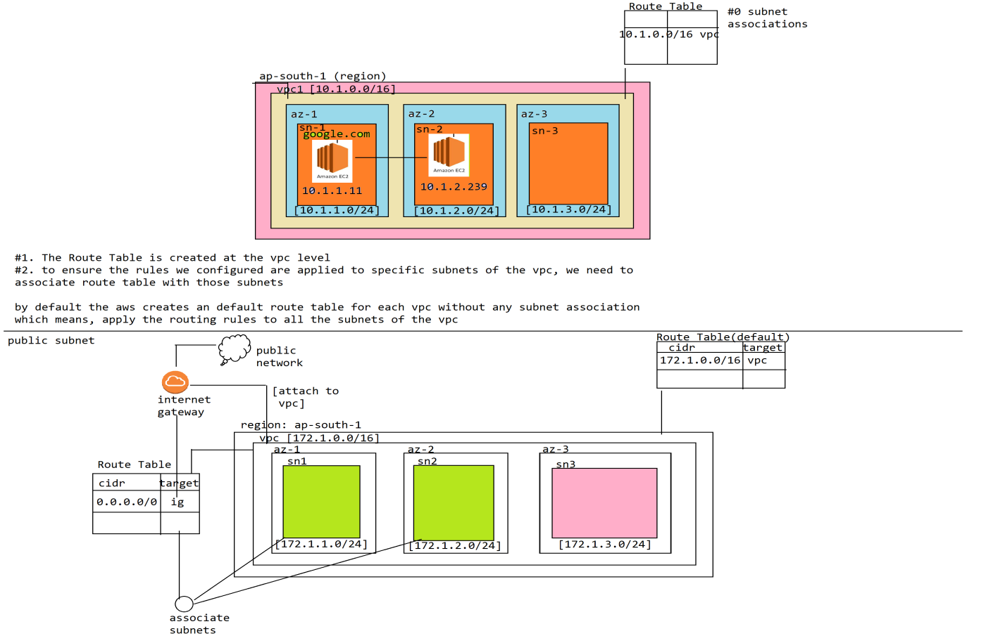

There are 3 types of subnets are there

1. private subnet

2. public subnet

3. hybrid subnet

**#2. public subnet**

1.

crazyeatsvpc [172.1.0.0/16] [ap-south-1]

|-crazyeatspublicsubnet1 [172.1.1.0/24] [az-1]

|-crazyeatsprivatesubnet2 [172.1.2.0/24] [az-2]

2. internet gateway -> attach to crazyeatsvpc

|-crazyeatsig

3. route table [crazyeatspublicroutetable]

|-add subnet associate [crazyeatspublicsubnet1]

|-add routetable [0.0.0.0/0 -> IG]

**#3. Hybrid Subnet**

**What is Hybrid subnet?**

Hybrid subnet is partially open to the public network. all the outbound/outgoing traffic from the resources of the subnet are allowed and all the public network traffic towards the resources within the subnet are blocked/not accessible.

**When do we use it?**

when we are hosting the applications behind the loadbalancer, we dont want public network resources to access our subnet resources or application directly, but the resources/application that is running within the subnet should be allowed to access the public network. because all the traffic to our application running within the subnet is routed throught the loadbalancer, so there is no need of our application to be directly exposed to the public. To handle this requirement we need to host our application on hybrid subnet.

**How to create a subnet as Hybrid subnet?**

To create a subnet as Hybrid subnet, the aws cloud platform has provided NAT Gateway through which the traffic from the subnet resources to the external network should be routed through.

The NAT Gateway is a network router that works based on Network address translation mechanism, which means

1. all the external network traffic towards the subnet resources are not supported, because our subnet is technically a private subnet. So inbound traffic is not possible since the resources of our subnet are not exposed.

2. all the outbound/outgoing network traffic from the subnet resources are routed through NAT Gateway. The NAT Gateway upon receiving the request, it would replay the request to the public network resources as if the request is being originated from NAT Gateway itself (thus hiding the subnet resources from the external network). upon receiving the response the NAT Gateway will route the response back to the original sender of our subnet resource.

For NAT Gateway to route the request to the public network resources it should be created on a public network only.

2. we need to create an route table within the vpc by associating the subnet and add an routing rule to route the public network traffic through the NAT Gateway.

**Bastion host or jumpbox:**

How to ssh or connect the private subnet or hybrid subnet resources from the public network to carry installations, configurations and maintainance activities?

To connect to the resources of a private or hybrid subnet we need to use bastion host or jumpbox. A bastion host or a jumpbox is nothing but an ec2 instance provisioned temporarily on a public subnet of the same vpc through which we can access any of the resources across the subnets of the vpc.

upon completing the maintainance activity we generally de-provision the bastion host

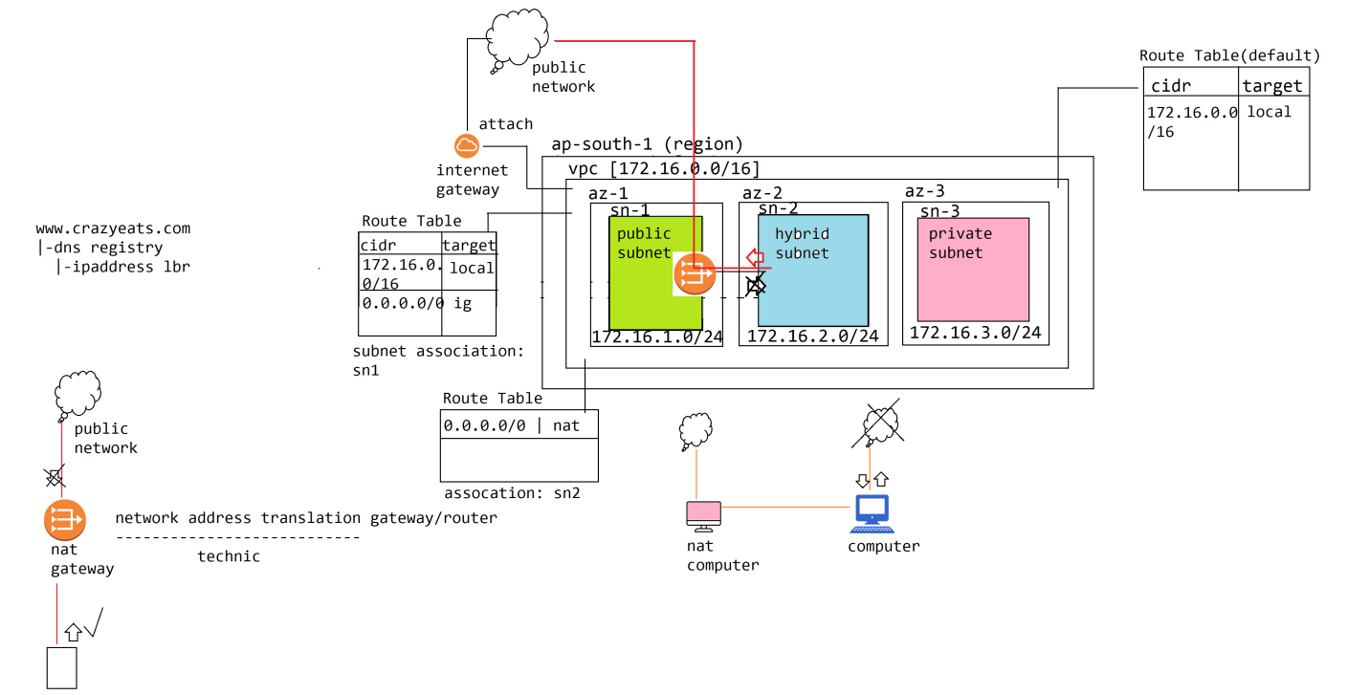

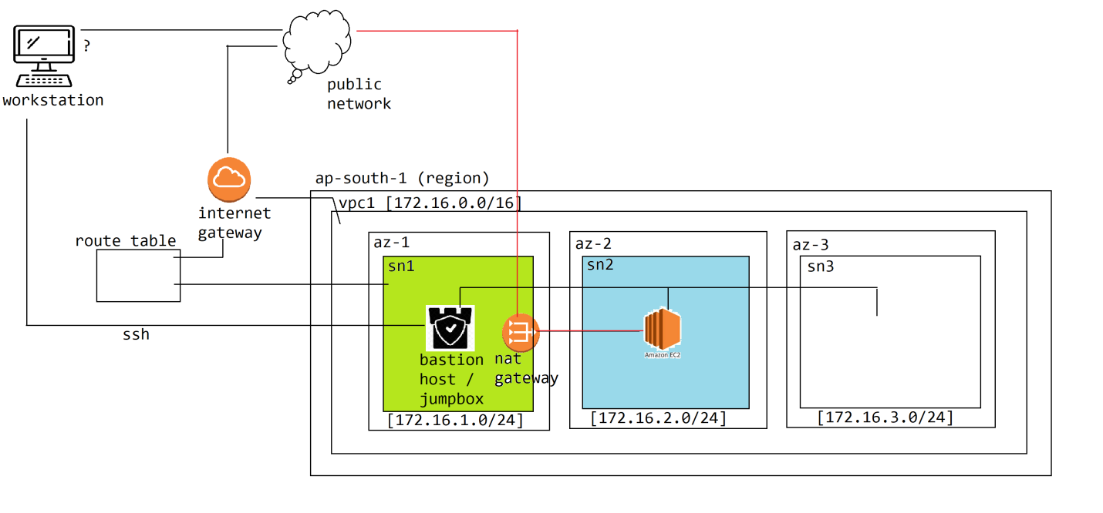

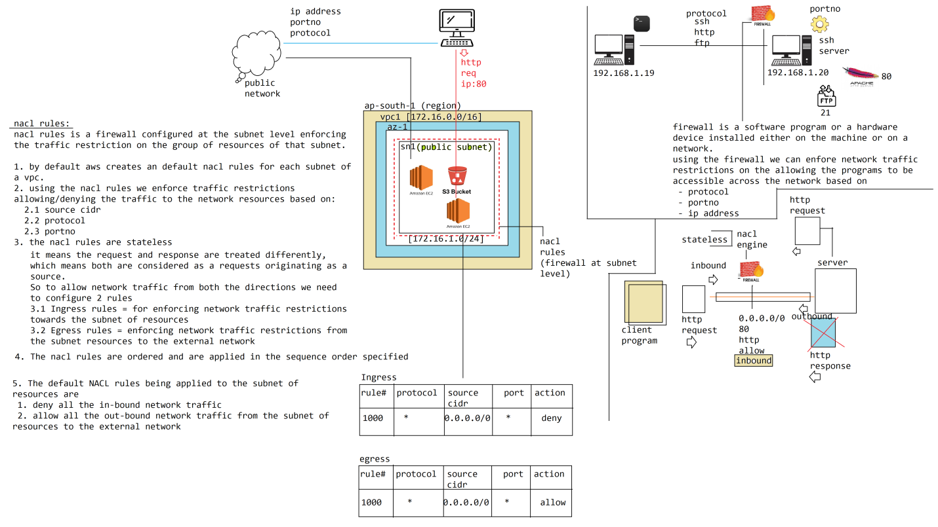

Hybrid Subnet

1. ap-south-1 (region)

2. toylandvpc [172.16.0.0/16]

3. subnets:

- toylandpubsn1 [172.16.1.0/24]

- toylandhybridsn2 [172.16.2.0/24]

- toylandprivatesn3 [172.16.3.0/24]

4. toylandig

- attach to toylandvpc

- toylandigrt

- associate: toylandpubsn1

- route: 0.0.0.0/0 -> toylandig

5. toylandng

- attach to the toylandvpc

- choose toylandpubsn1

- allocate elastic ipaddress

- toylandngrt

-> associate: toylandhybridsn2

- route: 0.0.0.0/0 -> toylandng

ec2 instance - public subnet = external network we can SSH

ec2 instance - hybrid subnet or private subnet = external network we cannot SSH

only way is through bastion host/jumpbox from public subnet

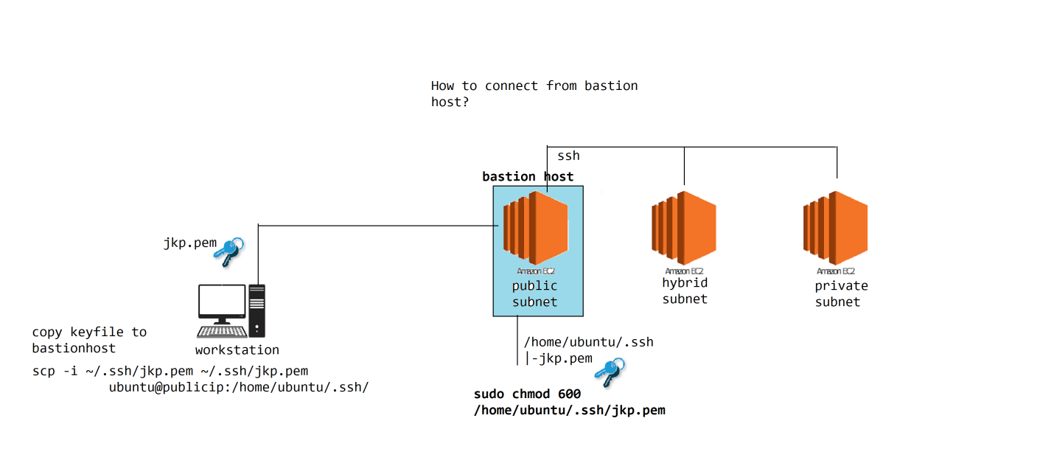

What are NACL rules, what is the purpose of them?

NACL stands for Network Access Control List is an firewall setup at the subnet level.

What is NACL, why do we need to use it?

NACL stands for network access control list, it is a firewall configured at the subnet level to enforce traffic restrictions on the group of resources of a subnet

1. By default when we create an vpc and subnets, the aws cloud platform creates default nacl rules for all the subnets of the vpc

2. Through the help of NACL rules we can enforce traffic restrictions on the subnet of resources based on

1. source cidr

2. protocol

3. port

allow/deny the network traffic to the resources

3. NACL rules are stateless

1. Stateless refers to the request and response are treated separately. NACL Engine doesnt keep track of a request to identify and allow the response for that request. so we need to separately configure inbound/oubound rules in allowing the network traffic in both the directions

2. To allow network traffic in both the directions we need to configure separately

- Ingress = refers to the rules to applied in allowing the in-bound network traffic

- Egress = refers to the rules to be applied for allowing the network traffic from subnet of resources to the external network traffic

4. NACL rules are ordered, which means each rule is given an priority or sequenceno in which the rules has to be applied.

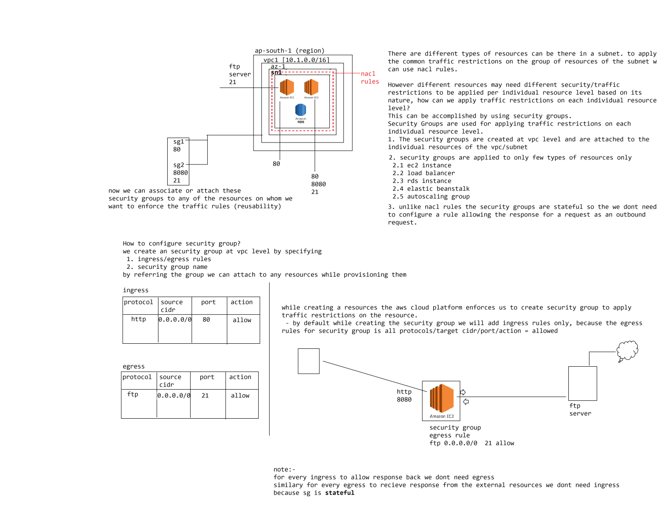

What are security groups, why to use them?

security groups

security groups are used for enforcing traffic restriction on an individual resource unlike the NACL used for enforcing traffic restrictions on the group of resources on a subnet level

1. security groups are created at the vpc level, so that those can be reused by attaching to the individual resources of the vpc/subnet

2. security groups are stateful which means it can keep track of a request/response

We can configure Ingress and Egress rules in allowing inbound/outbound network traffic from the resource of the vpc/subnet.

Statefull means:-

- If we configure an ingress rule we dont need to configure an egress rule to allow the response for the request from the source of the vpc/subnet

- Similar to the above, if we configure an egress rule we dont need to configure ingress rule to receive response from the external network for the request our resource has sent from the vpc/subnet

3. Security Groups can be applied only for few types of resources only

1. ec2 instance

2. elastic beanstalk

3. load balancer

4. rds instance

5. autoscaling group

while creating an resource within an vpc of a subnet, aws cloud platform enforces us to create/select an security group if applicable for that resource.

based on the type of the resource, aws configures the default ingress/egress rules in a security group

for ec2 instances the default security group configuration shown up

ingress:

ssh 0.0.0.0/0 22 allow

egress:

* 0.0.0.0/0 * allow

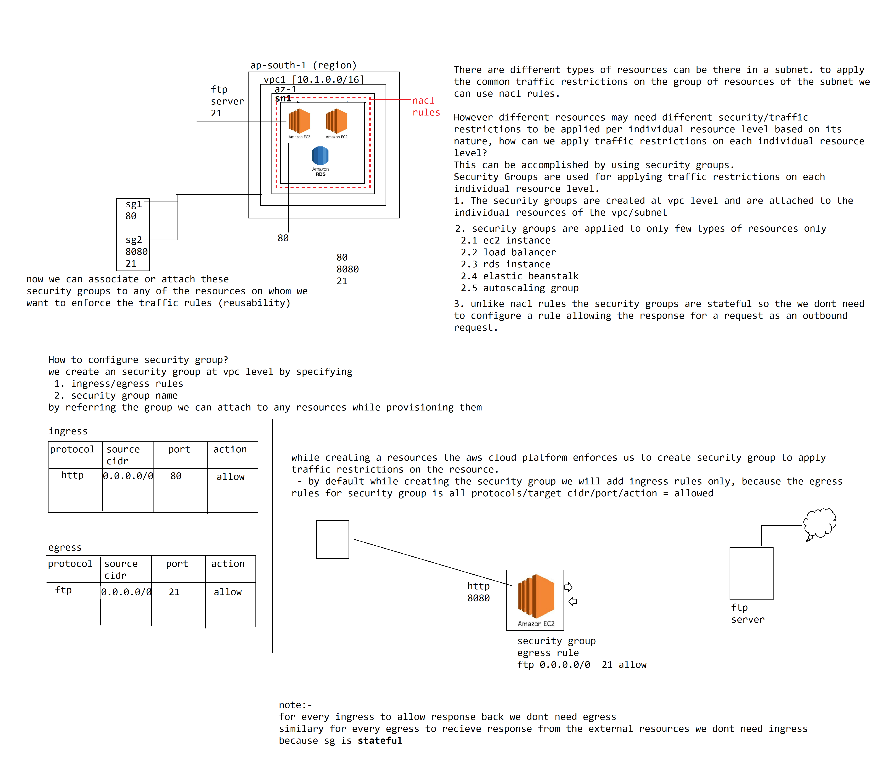

**security groups**

security groups are used for enforcing traffic restriction on an individual resource unlike the NACL used for enforcing traffic restrictions on the group of resources on a subnet level

1. security groups are created at the vpc level, so that those can be reused by attaching to the individual resources of the vpc/subnet

2. security groups are stateful which means it can keep track of a request/response

We can configure Ingress and Egress rules in allowing inbound/outbound network traffic from the resource of the vpc/subnet.

**Statefull means:-**

- If we configure an ingress rule we dont need to configure an egress rule to allow the response for the request from the source of the vpc/subnet

- Similar to the above, if we configure an egress rule we dont need to configure ingress rule to receive response from the external network for the request our resource has sent from the vpc/subnet

3. Security Groups can be applied only for few types of resources only

1. ec2 instance

2. elastic beanstalk

3. load balancer

4. rds instance

5. autoscaling group

while creating an resource within an vpc of a subnet, aws cloud platform enforces us to create/select an security group if applicable for that resource.

based on the type of the resource, aws configures the default ingress/egress rules in a security group

for ec2 instances the default security group configuration shown up

ingress:

ssh 0.0.0.0/0 22 allow

egress:

* 0.0.0.0/0 * allow

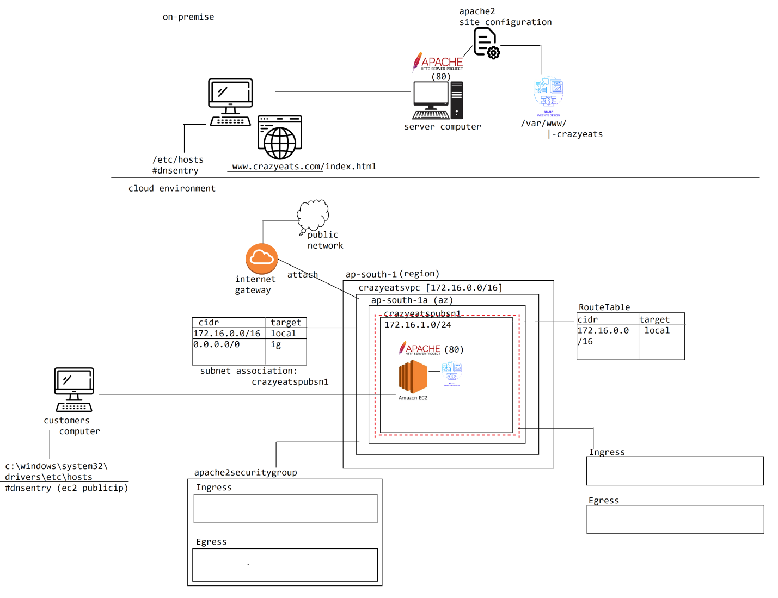

How to install and configure apache2 server to host an static web application?

**1. Install apache2 server**

sudo apt update -y

sudo apt install -y apache2

**2. scp crazyeats.zip into the ec2 instance**

scp -i ~/.ssh/awskp.pem crazyeats.zip ubuntu@ip:/home/ubuntu

**3. copy the crazyeats.zip into hosting directory**

cp crazyeats.zip /var/www

**4. extract the zip**

unzip crazyeats.zip

/var/www/

|-crazyeats

**5. write the site configuration file in routing the domain request to the DocumentRoot directory**

sudo touch /etc/apache2/sites-available/crazyeats.conf

sudo vim /etc/apache2/sites-available/crazyeats.conf

<VirtualHost *:80>

ServerName www.crazyeats.com

DocumentRoot /var/www/crazyeats

</VirtualHost>

6. sudo a2ensite crazyeats

sudo systemctl reload apache2

**Windows Host**

Add a local dns entry with the domain routing the request to apache2 server on the ec2 instance

open c:\Windows\System32/drivers/etc/hosts

ipec2 www.crazyeats.com

If the incomming network traffic is coming within private port range means, it is not an inbound request, it is an response for the request we send.

vpc peering

------------

virtual private cloud network (vpc)

vpc is an private network in which the resources of an vpc are isolated from any other resources of aws cloud platform.

For any resource on aws cloud platform there are 2 types of ip address assigned.

1. private ip address = is an internal ip address generated or assigned to any resources created on the aws cloud platform which is local to the aws network.

using the private ip address we can access the resources from other resources of the same vpc within the aws cloud platform.

There are 2 reasons for why aws cloud platform assigns for every resource a private ip address

1.1 For each resource to identify uniquely over the network and make them accessible internally within the cloud network aws assigns an private ip address

1.2 by using the private ip address the low network lantency and bandwidth speed at which the data transfers takes place will be really high, so it is always recommended to use private ip ony while communicating between the resource of the same vpc.

Note: private ip address are local to the aws cloud platform and cannot be used for accessing the resources from external network

2. public ip address = public ip address are assigned to the resources of public subnet. even though we assign public ip address to a private subnet resource, there is of no use, since the network itself is not connected to a public network using the public ip address the resource cant be reached.

The aws cloud platform supports 2 types of public ip addresses

1. empheral public ip address = is an public ip address assigned to the resource during provisioning of the resources by aws cloud platform. The empheral ip address assigned is an temporary ipaddress, that would be changed for that resource during a restart.

The empheral ip address is not assigned to the resource by default.

There are 2 ways we can assign empheral ip address to the resources.

1. while creating the subnet we need to choose auto assign public ip address to the resources of the subnet, then for each resource that is created within the subnet, aws cloud platform assigns an empheral ip address

by default when we are creating the subnet, the auto assign public ip is disabled.

2. while creating the resource for eg.. an ec2 instance, we need to choose the optional manually in assigning an ip address.

Post provisioning of the resource also we can assign ip address to an resource. we need to goto network interfaces section of the resource and attach a new nic and choose assign public ip address.

2. elastic public ip address

if we want the resources to be assigned with an permanent ip address then we need to use elastic ip address. aws allows us to create an elastic ip address pool in which we reserve the public ip addresses upto a limit of #5. there after we can attach/assign these ip address to the resources of our account.

even the resource has been deleted the ip address will be returned to the pool, the ip address will not be deleted.

elastic ip addresses are chargeable and if not being used we should release and remove them

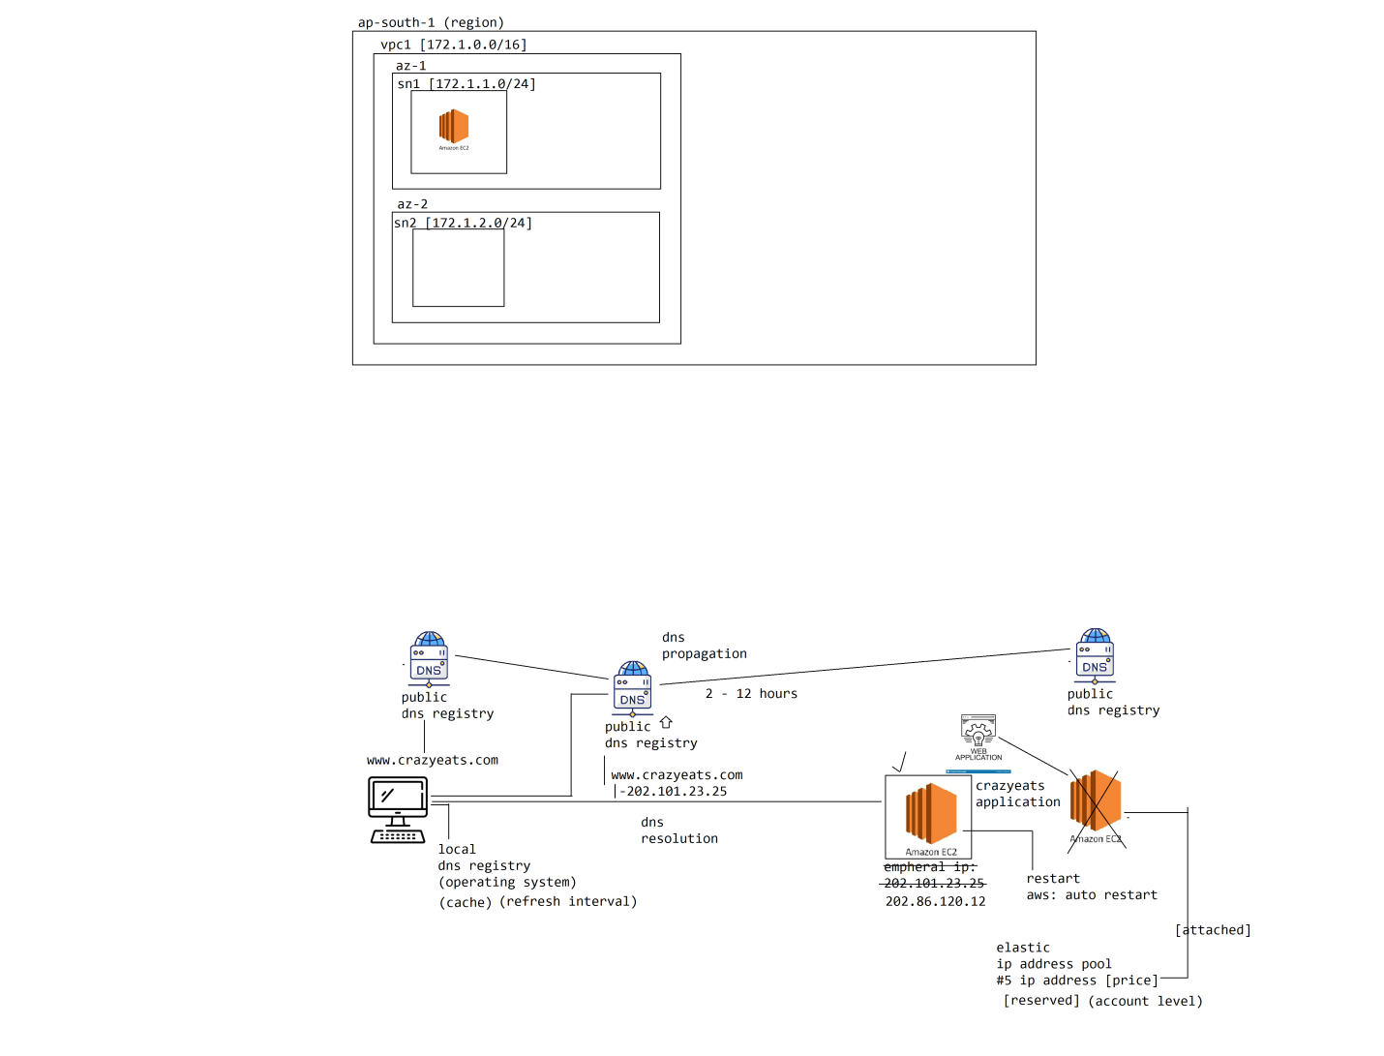

vpc peering

------------

virtual private cloud network is an isolated network of resources from other resources of the cloud platform.

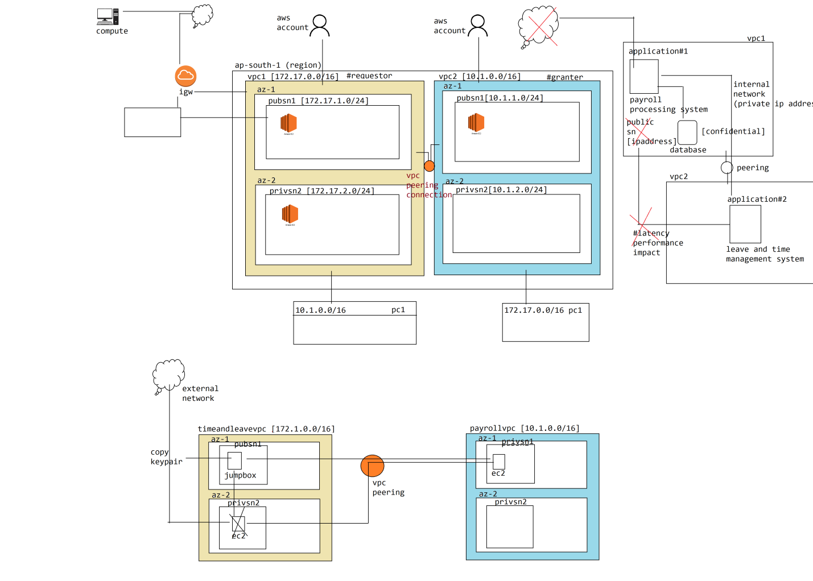

vpc peering

by default the resources within a vpc can communicate with other resources across the subnet of the vpc. If we wanted to make the resource of a vpc accessible externally we need to make the subnet as public subnet.

But what if we wanted the resources of our vpc to be accessible by the other resources of another vpc within the aws cloud?

There are many ways to make the resources accessible across the vpcs of the cloud platform

#1. make the subnet as public subnet, so that all the resources of that subnet in the vpc becomes accessible to other vpcs of the cloud platform. but there are dis-advantages with this approach

1.1 the resources will not only become accessible across the vpcs of the cloud platform, those are exposed to the external world as well, which poses an unecessary security threat

1.2 all the communicate to these public subnet resources goes through the external network channel due to which a huge network latency and delay in bandwidth transmission exists when compared with internal network of aws. so there is huge impact on the performance of the applications communicate over the external route.

#2. use vpc peering

vpc peering is a technic of inter-connecting or routing the network traffic across the vpcs of the aws cloud platform. by peering vpcs there is no additional data/network line will not be established, all the data between these 2 vpcs moves internally within the aws network thus providing high level security

The vpc peering can be done across any 2 different vpcs of

1. across the regions

2. across the aws accounts

But there are few conditions to be taken into account in order to perform vpc peering

1. The ip ranges of both the vpcs we wanted to peer should not overlap

2. Transitive peering, edge routing, internet gateway access is not supported

3. No Nat Routing between the vpcs

4. cannot resolve private DNS values across the vpcs

5. No cross referencing of security groups between the vpcs

#2. Database domain

There are 5 services under database domain

1. RDS (Relational database service)

RDS is not a database software product of AWS Cloud platform. There are lot of relational database management system softwares are available in the market like oracle, mysql server, postgres and db2 etc to use any of these database softwares on aws cloud platform, the cloud engineer has to take care of provisioning, scaling, backup and restoration of these products on cloud. instead aws has provided few of the popular database products as managed database services on aws cloud platform as PAAS services through RDS Service

For eg.. if wanted an oracle database to be used on aws cloud platform, we need to choose the database product and database configuration or parameters with which we wanted to have the database instance to RDS Service of aws cloud platform. It takes care of provisioning, managing the database cloud instance on the cloud platform.

2. Aurora db

Aurora database build by aws cloud platform on top of mysql server database. it is an relational database management system provided by amazon cloud. The Amazon cloud claims the aurora db is 5 times fater than the mysql server database interms of performance and data transfer rates

3. Dynamo db

It is an no-sql database management system built by amazon and provided as part of aws cloud platform. we can store petabytes of data in dynamo db and it is highly scalable

4. Elastic Cache

It is an distributed cache system provided by amazon cloud provider to implement server-side application caching

5. Redshift = database warehouse service used for processing and analyzing the data and generate reports

------------------------------------------------------------------------------------------------------------------------

What is a database management system, why do we need a database system?

A business always generates the data, the data that is generated by a business has to be kept/stored permanently for future usage for various different purpose.

How does the business can store the data permanently so that it can be used in future?

Write the data/store it on a booking keeping of records like ledger, sales book or petty cashbook etc. So that we can go through the records of data being written on the book for performing any operations.

There are several problems in keeping/storing the data on the physical medium like paper.

1. The information stored or written on a paper may not be legitimate and cannot be read/understood by other people

2. The paper has wear and tear and the data written on the paper might get fadded over the time and it is not permanent

3. accessing the data and searching the data is very difficult when we store the data on a book

4. in case if we have lost the book, there is no way to restore or recover it back

5. the information written on a book can be read by anyone who has access to it, so information is not secured

From the above we can understand storing the data on physical mediums like paper/books has lot of problems, since the business data has to be stored permanently for long interval of time we can store it on a computer system

The computer systems allows us to permanently store the data on the storage devices like harddisk, pendrive, floppy and cd devices. These are called secondary storage devices or permanent storage devices of a computer system that allows us to store the data permanently

To organize and manage in storing the data on these devices FileSystem technics are introduced. We can store the data in a File and organize or group them using Folders for quick/faster access.

File = is an datastructure that holds the memory address location of the actual data where it has been stored on the harddisk of the computer. by locating the address location of the data through the file we can access the information we stored on a harddisk. Each file will be given an unique name through which we can access the file and the contents of data through it.

Folder = Folder is a group of related files kept together to quickly access them

Now we can store the data on a computer system permanently using files/folders

database domain

database domain contains all the services related to managing the data, there are 5 services are there within it

1. RDS Service (Relational Database Service)

2. Dynamo DB

3. Aurora DB

4. Elastic Cache

5. Redshift

Why do we need to store the data permanently, what is the purpose of it?

always the business is going to produce data, and the business data has to be stored permanently for future usage and performing computation of the data.

To store the data permanently we can maintain the business data by writing on a piece of paper or by keeping the information in ledger books, petty cashbooks etc

There are dis-advantages in storing the data on the physical medium like paper or books

1. information written on a paper may not be legitimate and everyone may not be able to read and understand what has been written

2. business data grows over the time and at any point of time if wanted to retrieve the data in past, searching or identifying the data over the books is very difficult and time consuming operation and at somepoint of time we may not be able to locate the data as well

3. physical medium of storing the data has wear and tear and might be lost in future (it is not permanent)

4. not secured any one who has access to the books can read the information

5. there is no way to backup and restore in case of lost

from the above we can understand permanently storing the data on a physical medium (book/paper) has lot of problems, to overcome them permanent storage of data on the computer system has been introduced.

How to store the data permanently on a computer system?

The computer systems are attached with permanent storage devices like floppy, cd, pendrives and harddisk devices into which we can store the data permanently.

The process of permanently writing the data into these devices is called "persistency".

How to permanently store the data into the secondary storage devices of the computer?

To store and organize the data on the secondary storage devices of the computer, the FileSystem technics are introduced.

By using the FileSystem technics we can store the data interms of Files/folders on the computer system.

File: File is a datastructure that holds the address of the data where it resides on the physical storage device of the computer. Each file is associated with a name, through which we can easy locate and access the data stored on the secondary storage device of the computer

Folder: group of related files are kept together, so that those can be located and accessed quickly.

------------------------------------------------------------------------------------------------------------------------

How to store the data on the File of a computer?

We can store the data on a file as a set of sequence of characters (text data) inside them. we can use any of the text editors available in storing and reading the data from the files.

even though we can store characters of data manually in a file using the text editors, there are lot of problems are there in storing the data.

1. manually storing the data on a file is error prone. there is no way the data entered by the user is valid or invalid and all of the data gets persisted on to a file, which eventually leads to incorrent and un-usable data.

2. modifying the existing data on a file is very difficult and it is time consuming job, because we need to identify the data stored in past on the file place the pointer at the right location and modify it

3. searching and find the data within the text file is very difficult

4. we stored the data on a file to perform different types of calculations, but to use the data and perform calculations we need to manually read the data which is a time consuming job

5. manually reading and performing the computation on the data stored on a file may not result in accuraccy and takes lot of time as well.

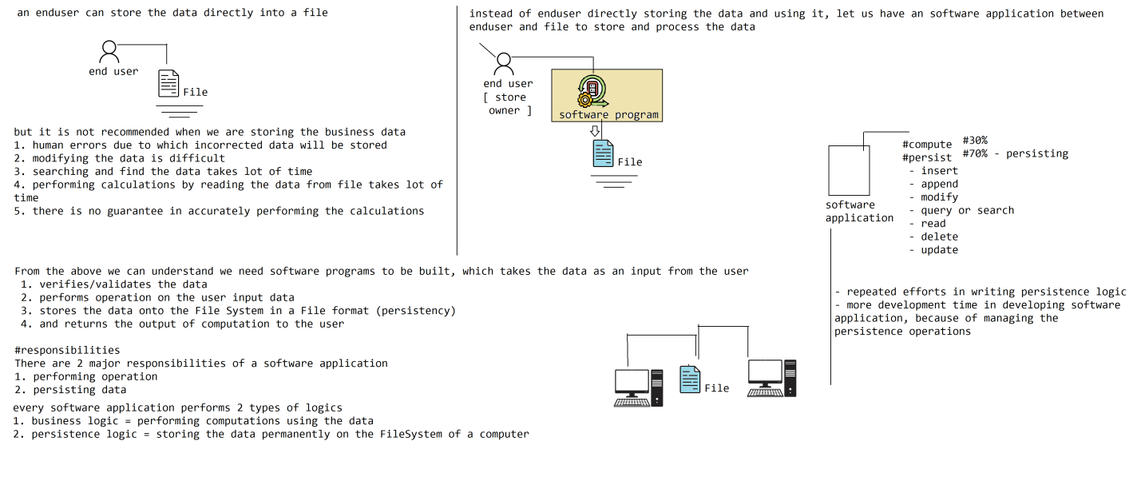

How to store the data on a File?

We can store the data on a File as a sequence of set of characters by using a text editor like a linux: vim, nano windows: notepad, wordpad etc

If we are storing the data manually on a File there are plenty of problems we run into

1. manually writing the data into the File is error prone job, there is no guarantee all the data written on to file is valid which will eventually leads to incorrect data and will not be helpful for performing operations

2. out of the data that is stored on the file, modifying the data is a tedious job because we need to locate the data that we wanted to modify manually and place the cursor position at the right place to replace or modify the existing data

3. searching and finding the data is verify difficult, querying the data with multiple filters is a very difficult job

4. we need to read the data manually to perform calculations on the data, which is a time consuming job and we cannot guarantee the accuracy in performing the operation

5. there is no security, any one can read the data stored on a File

To overcome the above problem, let us not store the data on a File manually rather use software applications to store and manage the data on the underlying Files of the system.

Instead of we directly writing the data into the File, we use software applications which will takes the data from the user and validates it and writes/manages the data into the File of the computer. There are lot of advantages are there

1. Any data that is written on to the File through the Software Program is guaranteed to be accurate/valid and can be used for performing operations

2. all the File manipulations like update, delete, inserting the data is taken care by the software program itself, the user dont need to manually locate and modify or delete the data

3. software programs are built by keeping the support of searching the data based on complex filter conditions, so we can quickly access the data we want through programs

4. The program by itself can read the records of data and perform operations on the data very quickly and high accuracy in performing the operation is guaranteed

5. software programs can use data security technics like encryption to store the data on a File, so that no one can read or understand the data from the file. So information stored on the file is highly secured

From the above we can understand if we are performing the operations and persisting the data through an software application we can eliminate all the problems in managing the data. But the software application to perform there activities should be developed by a developer.

There are lot of challenges involved in developing the software program/application which will carry these operations let us identify them

1. It looks like majority of code we are going to writing in the software applications contributes to persisting the data on the Filesystem, where in the developer would endup in spending little amount of time on writing the business logic due to which the time required for building the application will goes up

2. most of the programming languages doesnt have good support in storing the data onto the Files of the computer, so programmer has to write complex logic in managing the data on a File

3. due to the complexity of the code understanding and maintaining it is very difficult.

4. due to huge amount of code to be written in storing the data, there is more chances of bugs in the application

5. since it takes lot of time to build application for managing persistence operation, the cost of building the application goes high

6. By storing the data onto a File of a computer, it is not scalable and distributable across the computers

How to store the data permanently on the computer?

We can store the data permanently on a computer by writing onto the secondary storage devices by using FileSystem technic. FileSystem technic allows us to store and manage the data interms of Files/Folders.

We can manually write the data onto the File using text editors, but there are problems in directly storing the data on to a File

1. human errors, due to which incorrect data will be stored on to the File

2. modification of data is difficult because we need to identify the data we wanted to modify and place cursor at the right position within the File to modify

3. search and identifying the data is very difficult, it is tough to apply multiple filter conditions in searching and accessing the data

4. we need to manually read the data and perform operation on the data which will be

1. time consuming

2. leads to in-accurate in computation

5. data is not secured

To overcome the above problems in storing and organizing the data onto a File we need to use Software applications. The developers build the software applications using which we store/process the data on a File. Enduser will pass the data as an input to the Software application. The application validates the data performs operation on that data and read/writes the data onto the File

Advantages:-

1. all the data written onto the File through the application is being validated, so there is no chance that invalid data will be stored on the file

2. the application itself will locate the data and modify the data consistently across the File

3. Searching and identifying the data through complex filter conditions is easy.

4. application by itself can read and perform the operation on the data which will results in

1. faster operation

2. high accuracy

5. applications can use data security mechanisms while storing the data onto the file

-----------------------------------------------------------------------------------------------------------------------

Looks like all the disadvantages in storing/accessing the data manually onto the Files are overcomed through the help of Software applications. But there are challenges involved in building the software applications that works around the files.

The application developers has to use programming languages (like java, python, .net, php, scala etc) in storing and managing the data onto the Files of the computer. The primary purpose of building an software application is to perform business operations which results in high accuracy and faster computation. In addition to that we write the logic in storing/managing the data onto the Files as well.

So looks like while building the software application we are writing 2 types of logics

1. business logic

2. persistence logic

There are lot of challenges are there in building applications to perform persistence operations on the Files of FileSystem.

1. The programmer has to use programming language support in writing the code for storing/managing the data on the File of the computer. it looks like most of the programming languages has poor support in working with Files, so the programmer has to endup in writing lot of code in performing the persistence operations on the Files which leads to several problems

1. The complexity in writing the code for storing the data onto the File is very high

2. takes more amount of time in developing the application to perform persistence operation

3. The cost of building the application increases since we need to write more code and it is very complex and takes more time for building

4. The more the amount of code, the higher the bugs are

5. difficult to maintain

In addition to the above looks like across every application we need to write the code for persisting the data onto the File which looks like an repeatitive effort

To overcome all the above problems in persisting the data, the database management systems are introduced.

Database Management System:

-----------------------------

Database management system is a pre-built software application that contains the logic for storing/managing the data permanently on the underlying Filesystem of a computer. The application programmers dont need to write the code for storing/accessing the data from Files of the computer, rather they need to build the applications to communicate with database management system.

all the complexcities in storing/accessing the data are taken care by the database management system software.

There are lot of features of database management system are there

1. Many/most of the database management systems are distributed systems, so that we can run database software on one machine and application on another machine. The Software application connects to the database server remotely over the network in querying and storing the data. Since both are running on dedicated machines it results in faster throughput in running the application

2. The database management system abstracts the complexities in storing and accessing the data from the FileSystem of your computer, so that we dont need to bother about how to store/access the data which greatly reduces the time/complexity and cost of building the application

3. The database management systems provides tools/utilities through which we can periodically take the backup of the data and in the event of crach we can recover the data back quickly, through which we can always can restore the data back.

4. The database managment systems are highly secured in storing and allows us to access the data, there are authentication mechanisms in place allows us to controlly access the data and manage it

5. database management system softwares supports clustering due to which we have plenty of advantages

1. scalability can be achieved in storing the data

2. scaled performance in carrying database operations

3. high availability

6. databases allows us to enforce constraint checks and data checks before allowing us to store the data

There are lot of advantages of using database management system

1. Database management systems are distributed software systems that can be accessed remotely

2. Database Management systems abstracts the complexity in storing/accessing the data from the underlying storage of the computer, so developer dont need to write complex logic in managing the persistence operations within the application.

3. Dataase management systems provides tools for backup and recovery of the data in case of crash

4. highly secured

5. Most of the database supports clustering by which we have many advantages

5.1 scaled storage = distributed storage of the data

5.2 scaled processing = through clusting we can achieve scaled performance in managing the data

5.3 high availability

6. we can enforce checks on the data that is written on the database, so that invalid data never goes into the system

There are lot of Software manufacturers who are producing/building/manufacturing the database software and distributing to the world. Few are opensource and many are commercial. We need to download and install the database management system software on our computer to use them

There are different types of database management systems are available

1. Hierarchial database

2. Network database

3. Relational database

4. Object oriented database

5. No-Sql or Semi-Structured database

6. Object storage database

In the above many are of them are not being used in the market and the popular database management system ares

1. Relational database

2. No-Sql database

3. object storage database

#1. Relational database management system

we wanted to always store fields of data that acts as an input in performing the operations using the data, not everything serves meaningful in carrying the operations.

To permit us to query and access the data from the database management system, the relational database managements systems allows us to define tables with columns with fixed size. So that we can store the data by adding records into the table

sales

customer_nm sale_date mobile_no email_address quantity total_amount discount paid_amount

peter 13/Aug/2022 939373839 peter@gmail.com 10 2500 250 2250

paul 13/Aug/2022 938339499 paul@gmail.com 11 3500 200 3300

as we stored the data in structured format with pre-defined columns in a table, database can understand the data we stored, so the database helps us in querying and filtering the data we are looking for rather than we accessing the entire data and filtering it

The relational database management systems provided an langauge called sql (structured query language)

based on the data structure we query(access) the data

select columns from table where column condition value

select * from sales where quantity >= 11

There are 6 different types of database management systems are there

1. Hierarchial database

2. Network database

3. Relational database

4. Object-oriented database

5. No-Sql / Semi-Structured database

6. Un-Structed / object-storage database

#1. Relational database management system

Relational database management system allows us to store the data interms tables. These are called as structured database management system.

Each table should be defined with columns with fixed size and the data will be stored in the tables by adding records into the table, which are also called as "tupples"

Why does the data is stored in table/structured format?

by defining the tables with fixed columns, what data has been stored within the tables is well-known to database management system, since all the data is structured the database management system can help us in querying, filtering and acessing the data easily. In addition all the data manipulation operations are taken care by database management system itself.

To work with querying or manipulating the data in the rdbms, the database has provided an standard language called "sql". it is english like language through which we can interact and ask the database to perform operations on the data based on the structure of the data

Why does the name relational database management system?

always the business data has relationship between them, so one way to represent relationship of the data is keeping the data together by defining in one table.

but it is not recommended to store the entire data of the business into one single table, because we run into data anamolies

1. duplicate

2. updation

3. insertion

4. deletion

Instead break the data into multiple tables and store them separately to avoid anomolies. But to establish relationship between the data we need to define primary keys and foreign keys in the tables.

primary key = a column defined inthe table, which contains unique value among the records of data within that table. no 2 records contains same value in that table, so that we can identify the record using the primary key value and can be used as foreign key in another table to establish relationship

foreign key = a column defined in a table referring to the primary key column of another table through which we can establish relationship

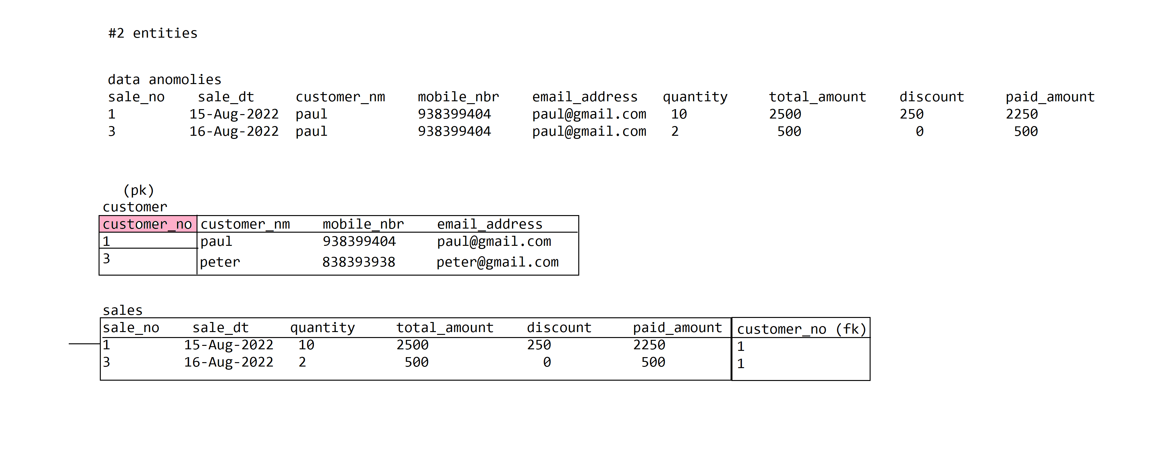 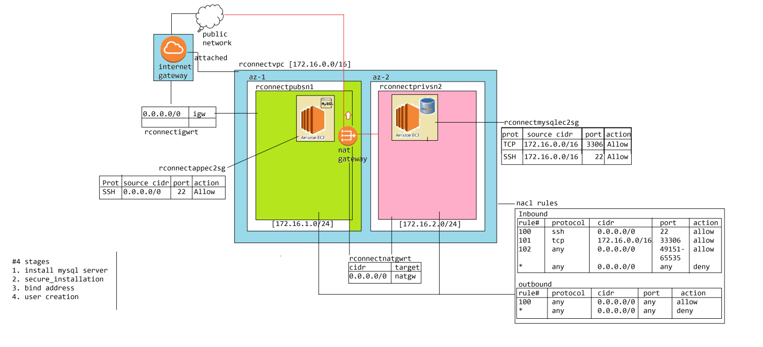

How to install mysql server? [private ec2 instance machine]

1. Install MySql Server

sudo apt update -y

sudo apt install -y mysql-server-8.0

2. alter mysql_native_user password

sudo mysql -uroot

alter user 'root'@'localhost' identified with mysql_native_password by 'root';

exit

2. configure secure access

sudo mysql_secure_installation

3. change the bind address

sudo vim /etc/mysql/mysql.conf.d/mysqld.conf

change from 127.0.0.1 to 0.0.0.0

bind-address = 0.0.0.0

4. add new user and grant permission for access remotely

mysql -uroot -proot

create user 'rconnectuser'@'%' identified by 'welcome1';

grant all privileges on *.* to 'rconnectuser'@'%';

exit

How to install mysql client? [public ec2 instance machine]

1. sudo apt update -y

2. sudo apt install -y mysql-client-8.0

#2. Database domain

1. RDS Service [Relational database Service]

For every application we need database as an backend storage system, we can provision an ec2 instance on aws cloud platform and can install and configure an relational database product like an mysql server or oracle database on the cloud instance.

But there are lot of challenges in provisioning, configuring and managing the rds database by our own:

1. while hosting an database server on the cloud infrastructure we need to take care of lot of aspects interms of network and security in allowing the database to be accessible for the applications within cloud network. To ensure greater level security we need design and plan the infrastructure up ahead

2. upon provisioning the cloud infrastructure, the devops engineer has to manually install and configure the database server instance which deals with several aspects of

1. product licensing

2. downloading the binaries

3. installing and configuring the server instance

3. to ensure the database server is always high-available we need to install on multiple ec2 instances across the availablity zones of the region and the ops engineer has to install and configure mysql server instance in active/passive install across the nodes of the vpc, which is quite complex

4. monitoring tools should be in place to ensure the database availablity

5. scaling the storage is very complex, because for scaling the storage we need to scale-up the ec2 instance which involves considerable amount of down time and impacts the business

6. scaling the database cluster for high traffic is very complex

7. backup and recovery is a continous job and is difficult to manage

From the above we can understand provisioning, installing and configuring the relational database server and manging and monitoring is a quite challenging job and requires

1. huge infrastructure

2. tools

3. and man power in monitoring and managing

Everyone requires an relational database server for running their application, rather we take care of provisioning and managing by ourself aws cloud platform has provided it as PaaS service

1. RDS Service

RDS stands for Relational database service, it is not an database server by its own rather it is managed service provided by aws cloud platform that supports provisioning and managing the popular relational database server products on aws cloud platform

The RDS Service takes care of

1. installing database software

2. configuring

3. security

4. high availability

5. scalability (storage/performance)

6. backup and restore

7. patching

8. upgradation

etc

all the cloud lifecycle operations on the underlying database server, so that with no time we can quickly take our application on production.

RDS Service supports provisioning and managing the below database server softwares on aws cloud platform

1. MySql Server

2. Oracle database

3. Postgres

4. MariaDB

5. Microsoft SqlServer

In addition to the above there is an relational database service provided by aws called "Auroradb", which is an direct service of aws cloud platform

How to provision and connect to an RDS Service on aws cloud platform?

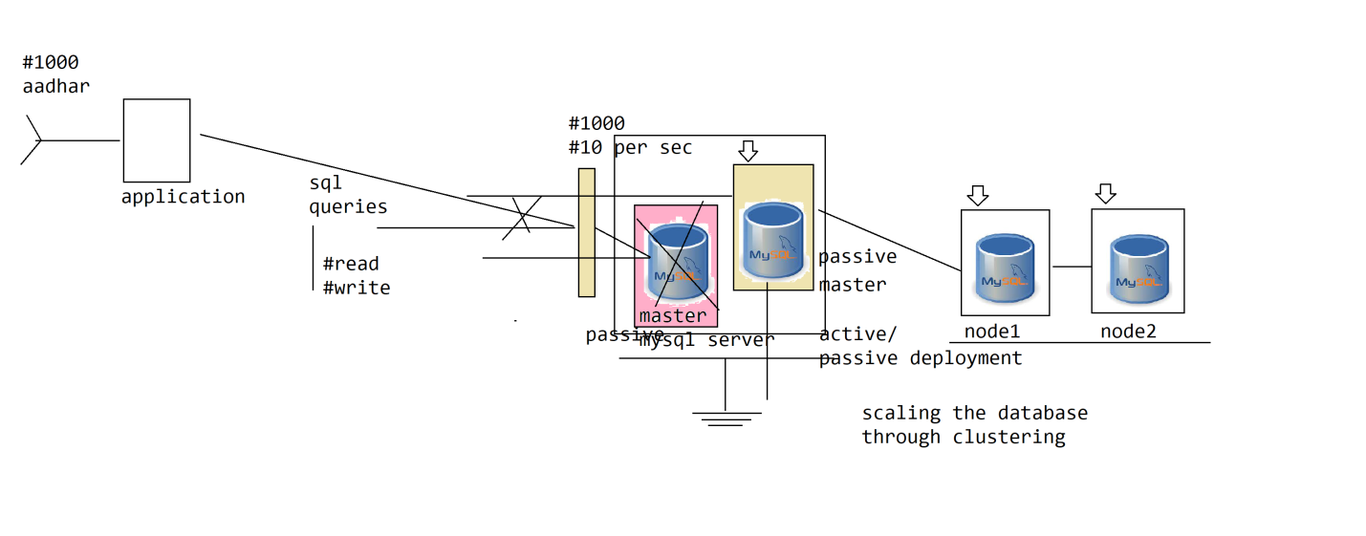

What is RDS Service, why do we need to use it?

RDS stands for relational database service which is an managed service provided by the aws cloud platform. RDS service provisions and manages most of the popular relational database products in the market like

1. mysql server

2. oracle database

3. postgres

4. mariadb

5. microsoft sql server

its an PaaS service that takes care of managing all the lifecycle operations on the underlying database instance provisioned through RDS Service like

1. provisioning

2. deprovisioning

3. scaleup

4. scaledown

5. scaleout

6. scalein

7. backup

8. recovery

9. patching

10. upgradations

-----------------------------------------------------------------------------------------------------------------------

How to provision MySql Server datatabase instance using RDS Service of AWS?

1. create vpc

CIDR = 172.16.0.0/16

NAME = rconnectvpc

2. create subnets

The RDS Database is always recommended to be provisioned in private subnet only for security and accessibility reasons

So create multiple private subnets (across the AZs) for HA/Scalability so that RDS can provision the database instance across any of the private subnets.

#2 private subnets

rconnectprvsn1 [172.16.1.0/24]

rconnectprvsn2 [172.16.2.0/24]

#1 public subnet [jumpbox] = to connect to mysql service provisioned above and verify

rconnectpubsn3 [172.16.3.0/24]

1. create internet gateway

NAME=rconnectig

2. attach to vpc [rconnectvpc]

3. create route table at the vpc level

NAME = rconnectigrt

Subnet associate: rconnectpubsn3

Route: 0.0.0.0/0 -> rconnectig

3. Navigate to RDS Service

1. From the left navigation menu choose create dbsubnet group

1.1 click on create dbsubnet group

1.2 choose the vpc

1.3 choose the AZ from where we want to pick subnets from

1.4 choose the subnets within the vpc->AZ where you wanted RDS Service to provision database instance and maintain replicas

What is the purpose of dbsubnet group?

when we ask RDS service to provision an database instance by choosing the dbsubnet group, it will takes care of replicating the db service instance on multiple subnets of the group for HA and scalability. There are 2 reasons for creating db subnet group

1. High availability

2. scalability

4. create an security group at vpc level for dbinstance

rconnectmysqlsg

Ingress

TCP 172.16.0.0/16 3306

Egress

ALL 0.0.0.0/0 ANY

jumpboxsg

Ingress

SSH 0.0.0.0/0 22

Egress

TCP 0.0.0.0/0 ANY

5. Start creating RDS Service Instance by going to RDS Service from menu

1. click the create database

2. choose the database type we wanted to provision using RDS Service

1. aurora db

2. mysql server

3. oracle

4. postgres sql

5. maria db

6. microsoft sqlserver

3. choose the version of the mysql server we wanted to provision

4. the provision mode

1. standard = we need to choose and pick the configuration options using which we wanted to create the instance

2. easy = the default options will be auto-populated and we dont need to configure any values

5. Choose the instance Type

1. production = all the production capabilities in running the sql instance are enabled

1. Multi-AZs (active/passive) provisioning

2. EBS Storage Classes

3. backup policy

4. shape

5. enabling autoscaling

2. development/test

3. freetier

6. choose vpc

7. choose subnet group

8. security group

9. shape

10. choose ebs storage class

11. autoscaling configurations

12. dbsinstance name

13. username/password

14. authenticationType (username/password, IAM Authentication, SAML/Kerbores Authentication)

15. ip address (public/no)

16. launch

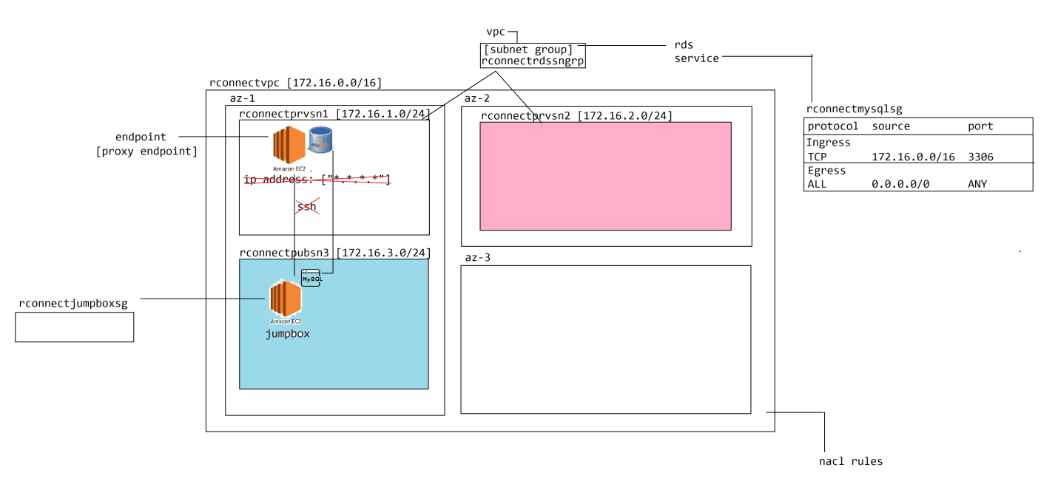

Database domain:

There are 5 services are there in database domain

1. RDS Service

2. DynamoDB

3. Aurora

4. Elastic Cache

5. RedShift

DynamoDb

DynamoDb is an NoSql database provided by the aws cloud platform as an alternate to the RDS service.

Why do we need No-Sql databases when we have RDBMS databases?

There are problems or limitations with RDBMS database due to which there are not been an ideal choice for few types of applications.

If we look at the relational database management system, they allow us to store the data in structured format by defining data interms of tables with fixed-set of columns within it.

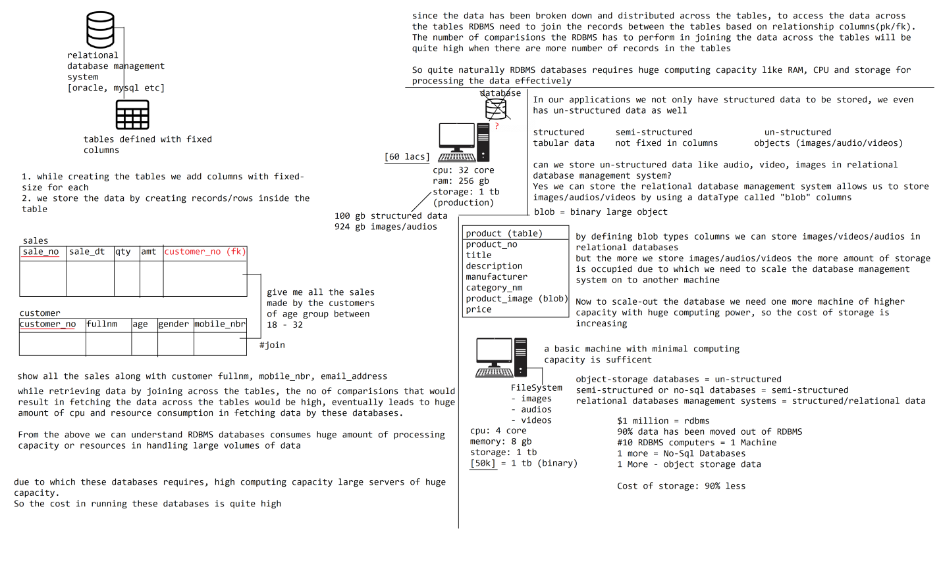

No-Sql database or semi-structure database

Even though we have relational database management systems to store and query the data effectively, still we have certain limitations with them, alternate to them the No-sql database systems are introduced

Following are the dis-advantages/limitations of relational database management system

1. Relational database management systems allows us to store the data in structured format where each record in the table has fixed set of columns within them. But not all the data in the real-world is not structured, the skeleton or the attributes of the data we wanted to store per each record for an entity might vary

For eg.. we wanted to store the information about mobile phone in the database, so we can create an mobile_phone table with all the possible information of the mobile to be captured. but all the mobile phones may not have all the features and specifications, in such case when we are storing a basic mobile information most of the columns are left with default values or null due to which huge amount of memory will be wasted while storing such data

Let us take another example like we wanted to store information about the product. We cannot store information about the products in a RDBMS tables since the structure/attributes of the data is not fixed/same for all products

even though we can model such un-structured data in relational tables, the data model becomes quite complex and difficult to program

2. not ideal or suitable for storing non-textual data

There are limitations or dis-advantages with RDBMS databases

1. only suitable for storing structured data of fixed set of columns per each record within the table. poor at handling semi-structured data either, if we try to store semi-structured data it results in

1.1 huge memory wastage

1.2 or the complexity of the schema would be high and difficult to program

semi-structured = each record may not have the same set of columns to store the data, so the columns of the data we wanted to store is not fixed

2. the cost of storing the data would be very high while storing the data in relational database management system, because these databases requires huge computing capacity for storing and processing the data, they need high-end server grade machines to install these databases.

So the storage cost of data = along with storage cost + computing resources cost which is results in huge price of storage.

So these databases are not ideal choice for storing non-relational data like videos, audios, images etc

3. difficult to achieve highest-level of concurrency

RDBMS databases supports transactionality so we cannnot achieve highest-level of concurrency

To overcome the above problems the no-sql or semistructured and object-storage databases are introduced

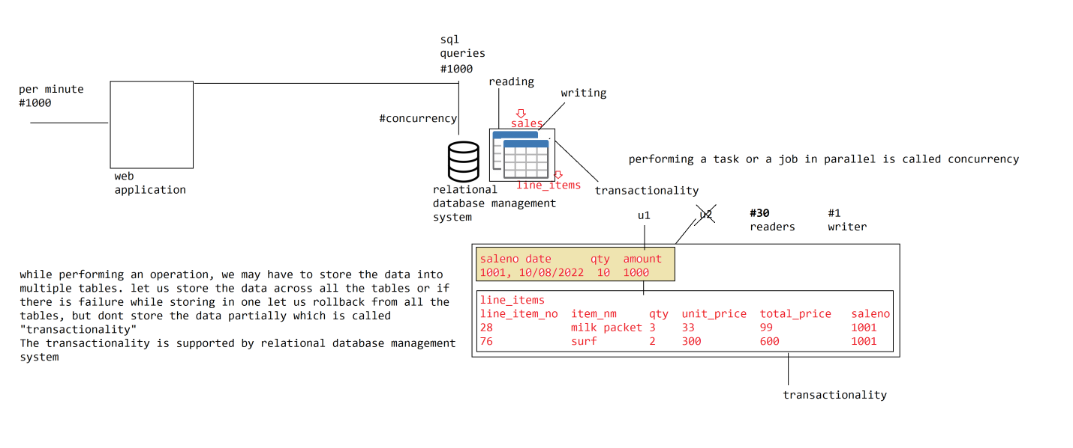

There are few limitations or dis-advantages with RDBMS databases

1. supports only structured data, but not all the data is structured, and if we store semi-structured data in RDBMS

1.1 huge amount of memory will be wasted

1.2 schema becomes quite complex and difficult to program

2. the RDBMS are not recommended to be used for storing audios, videos and images which are un-structured data. by storing these data in RDBMS the underlying machines quickly runs out of resources and requires scaling the database due to which the cost of storage increasing

3. we cannot achieve highest level of concurrency, because these databases are transactional

From the above we can understand it is not recommended to store semi-structured or un-structured data in RDBMS, till now there is no alternate systems available people used to store the data in RDBMS. Thereafter identifying the problems with RDBMS to eliminate or overcome them other types of database management systems are innovated and introduced.

1. no-sql databases

2. object storage databases

1. no-sql database

no-sql databases are designed to store semi-structured data, the way the data is stored in no-sql databases differs from product to the product there is no standard format or hard and fast rule in the way we the no-sql databases supports storing data

since different products has different storage formats, let us generalize and understand the way these databases supports storing the data

In no-sql databases we dont define tables with fixed-set of columns, because different records data has different columns.

So here we dont create tables rather we create a data structure which is loosely structured called usually "collections".

For eg.. to store mobile phones information we create mobile collection in which we store information about various different mobiles. Similary we create product collection in which we can store information about different products of varied fields/columns

Now we store the data as records in the collection, each record will contain key/value of data. In a record we can define any number of keys and values which differ from another record of data in the collection

product

#1 [product_no=837

model="Iphone 13 Pro Max"

color="Red"

storage="128gb"]

[product_no=938

model="Samsung 32 inch LED tv"

sound="5.1 Dolby Atmos"

displayType="LED"

pixel="1Million"

]

Each row can have different keys and different values, as the structure of the data is not same these are called "semi-structured" databases. So to access the data from these databases we cannot use sql for querying the data so these are even called "no-sql" databases

These databases are suitable for storing

1. semi-structured data which doesnt have fixed columns in nature

2. no relationship between the data

3. dont need transactionality

There are lot of no-sql database management systems are available in the market produced/developed by various different vendors

1. mongodb

2. casendra

3. couchdb

4. oracle bigdata

5. aws dynamo db

6. graph db

each of these databases has their own model of representation allowing us to store the data

For eg..

In mongodb allows us to store the data interms of json format

To store data in mongodb we need to create a collection per each type of data. For eg.. we want to store product information create products collection

In collection we store data as collection documents

we can image a collection = table of RDBMS

- document = record in the table

- key/value = column/value (fixed)

(varied)

product [

{

"product_no": "938",

"title": "Samsung LED Tv",

"manufacturer": "Samsung",

"price": "100000"

},

{

}

]

But when it comes to cassendra database it is called columunar database it allows us to store the data in key/value pair format as how we described above

Now AWS DynamoDB is also an no-sql database management system that should be used for storing semi-structured data.

AWS DynamoDB database

----------------------

AWS Cloud Platform has provided an no-sql database service which is DynamoDB that allows us to store the data by definining interms of keys/values

There are plenty of no-sql database products available in the market, then why should we use DynamoDB in storing the semi-structured data

There are lot of advantages are there with DynamoDB database

How does no-sql databases stores the data?

There is no standard format in storing the data by the no-sql databases, different database products stores the data in different format but we can generalize and can understand.

since no-sql database supports storing semi-structured data where each record may not have all the columns of data so these databases will not store the data in structured tables

rather these databases stores the data in collections. In each collection we store doc/record of information where each record has a varied key/value pair of data

In case of mongodb it supports storing the data interms of docs in a collection. each doc is stored in json format represent a record of information

Cassendra is called columnar database which supports storing the data in key/value pair

In addition to the above aws cloud platform has provided dynamodb as an no-sql database management system.

DynamoDb

--------

There are plenty of advantages of using dynamodb when compared with other no-sql databases available in the market

1. DynamoDb is an managed service that is hosted by the aws cloud platform which takes care of all the lifecycle operations like provisioning/de-provisioning, scaleup/scaledown, scale-out/scale-in, backup/restore etc. if we are using any of the third-party provider databases, these has to be manually takencare by the ops engineer which is quite complex and huge cost in managing

2. Optimized for performance at scale = irrespecitve of amount of data being stored in the DynamoDb database we can achieve same level of consistency interms of performance while accessing the data from the database

3. High Availability / Durability = no matter always the database is available and the data is durable without loss

4. Integrate with other AWS Services

5. Cost effective usage based payment model

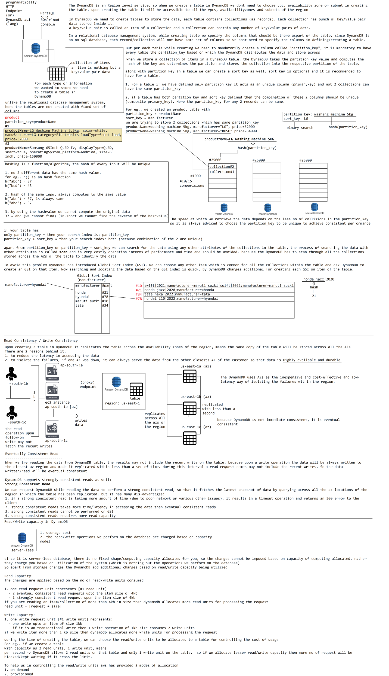

DynamoDB

DynamoDB is an managed no-sql database provided as part of the aws cloud platform. It is scoped to AWS Region and upon creating the table in a Region, it would be accessible across all the AZ, VPCs and subnets of the region.

For eg.. if we create a table called "orders" within a region ap-south-1 it will be scoped to ap-south-1 and is accessible across all the AZs of the region. we cannot create one more table within the ap-south-1 of the name "orders".

but we can create a table with name "orders" under us-east-1 without any problem.

DynamoDB supports multi-region replication where a table created in one region can be made accessible across other regions also within cloud platform

DynamoDB is serverless database, self-managed by AWS Cloud platform.

In DynamoDB we can store the data by creating the tables, while creating the tables in DynamoDB we dont need to specify the columns of data we wanted to store, since it is an no-sql database. In the tables we store collection of items, where each item is nothing but key/value pair of data (we can image a collection as a record in relational table)

For every table we create in DynamoDB we need to create a column partition_key, it is mandatory and based on the value of the partition_key only the data is distributed across the partitions of the table within the DynamoDB cluster.

If a table has only the partition_key then it acts as primary_key of the table, so no 2 collections of the table can carry the same value for the partition_key

The DynamoDB takes the partition_key of the collection and computes the hash value of partition_key we provided and computes the partition in which the data has to stored within the table, so that the data is distributed uniquely across the partitions. So while lookingup for the data based on partition_key the DynamoDB again computes the hash value for the partition_key we supplied and determines the partition in which the data is stored and retrieves it quickly.

If we see even the data is scaled to terrabytes as well just with one single lookup we can fetch the data consistently across the collections we stored in the table

In addition to the partition_key we can create one more column called sort_key. if a table contains partition_key and sort_key then together both becomes primary_key of the table.

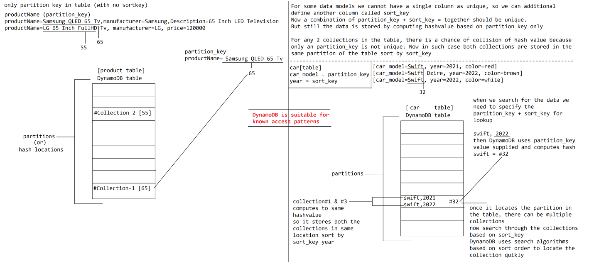

There are limitations with derived queries

1. we cannot apply joins queries

2. we cannot use groupBy and having clauses

To overcome the above problem the declarative queries are introduced.

declarative queries

In declarative queries we can declare a method in the repository interface binding with an jpql query to be executed upon invoking the method using the repository object. the query can take parameters which are supplied through method arguments and will be substituted as parameters in query during execution.

Here we dont need to follow any method naming conventions while declaring the methods, since we are only going to bind the jpql query rather than being derived automatically

we need to use declarative queries for complex requirements like

1. joins

2. groupBy

3. or complex query clauses

interface TripRepository extends JpaRepository {

@Query("from Trip trip where trip.days between ?1 and ?2")

List<Trip> getTripsBetweenDays(int minDays, int maxDays);

}

here the parameters in the query are substituted based on positions, but if more query parameters are there then it is difficult to map positional parameters to the query to overcome the problem

NamedParameters are introduced

interface TripRepository extends JpaRepository {

@Query("from Trip trip where trip.days between :mnDays and mxDays")

List<Trip> getTripsBetweenDays(@QueryParam(name="mnDays") int minDays,@QueryParams("mxDays") int maxDays);

}

@Entity

@Table("delivery_associate")

class DeliveryAssociate {

@Id

@GeneratedValue(strategy=GenerationType.IDENTITY)

int deliveryAssociateNo;

String fullname;

String mobileNo;

String emailAddress;

@OneToMany(mappedBy="deliveryAssociate")

Set<Parcel> parcels;

// accessors

}

@Entity

@Table("parcel")

class Parcel{

@Id

@GeneratedValue(strategy=GenerationType.IDENTITY)

int parcelNo;

String description;

int weight;

double shippingCharges;

@ManyToOne

@JoinColumn(name="delivery_associate_no")

DeliveryAssociate deliveryAssociate;

// accessors

}

1. I want all the parcels scheduled to be delivered by the deliveryassociate name: paul

from Parcel parcel where parcel.deliveryAssociate.fullname=? #implicit query

interface ParcelRepository extends JpaRepository<Parcel, Integer> {

@Query("from Parcel parcel where parcel.deliveryAssociate.fullname=?1")

List<Parcel> getParcelsByDeliveryAssociate(String deliveryAssociateName);

}

2. return all delivery associates who are delivering the parcels of weight more than 50 kg

from DeliveryAssociate da inner join on da.parcels parcels where parcels.weight > ?

interface DeliveryAssociateRepository extends JpaRepository<DeliveryAssociate, Integer> {

@Query("from DeliveryAssociate da inner join on da.parcels parcel where parcel.weight > ?1")

List<DeliveryAssociate> getDeliveryAssocateByParcelWeight(int weight);

}

Read capacity/ Write Capacity

The billing on DynamoDB takes place based on read/write units consumed. The DynamoDB is server-less so there is no computing capacity reservered for usage, so the only cost parameter that can be taken into consideration is based on usage of the database.

while is nothing the read/writes we perform on the DynamoDB

1. Read Unit

- 2 eventual consistent reads of size 4kb is considered as one read unit

- 1 strongly consistent read of size 4kb is considered as one read unit

if we read operation resulted in fetching the data more than 4kb more read units will be allocated

2. Write Unit

- 1 write of an item upto 1 kb in size

- 1 transaction write upon an item of size 1kb is considered as 2 write units

if more data has been writen as part of the write, the more write units will be allocated

While creating the table in DynamoDB the ops/cloud engineer can allocate the read and write capacity units for a table

For eg.. if we allocate 2 write capacity units and 4 read capacity units means

within a second for that table it allows

2 write operations of 1kb in size

1 transaction write of 1kb in size

(or)

4 write operations of 2kb in size

2 strongly consitent read of 2kb in size

are permitted on the table

if any thing beyond the capacity has been recieved, then DynamoDB blocks/keeps the requests under waiting for next interval

From the above we can understand choosing wisely the read/write capacity units are very important to allow operations to be performed on the table. DynamoDB allows us to allocate read/write capacity on table in 2 modes

1. provisioned

2. ondemand

1. provisioned

the cloud engineer is going to allocate fixed read/write capacity on table allowing to perform operations. the provisioned mode is the default mode under which a table will be created

2. ondemand

aws will automatically scaleup/down the read/write capacity of a table based on the usage.

-----------------------------------------------------------------------------------------------------------------------

Database domain

1. relational database service

2. auroradb

3. dynamodb

4. elastic cache

5. redshift

1. Elastic Cache

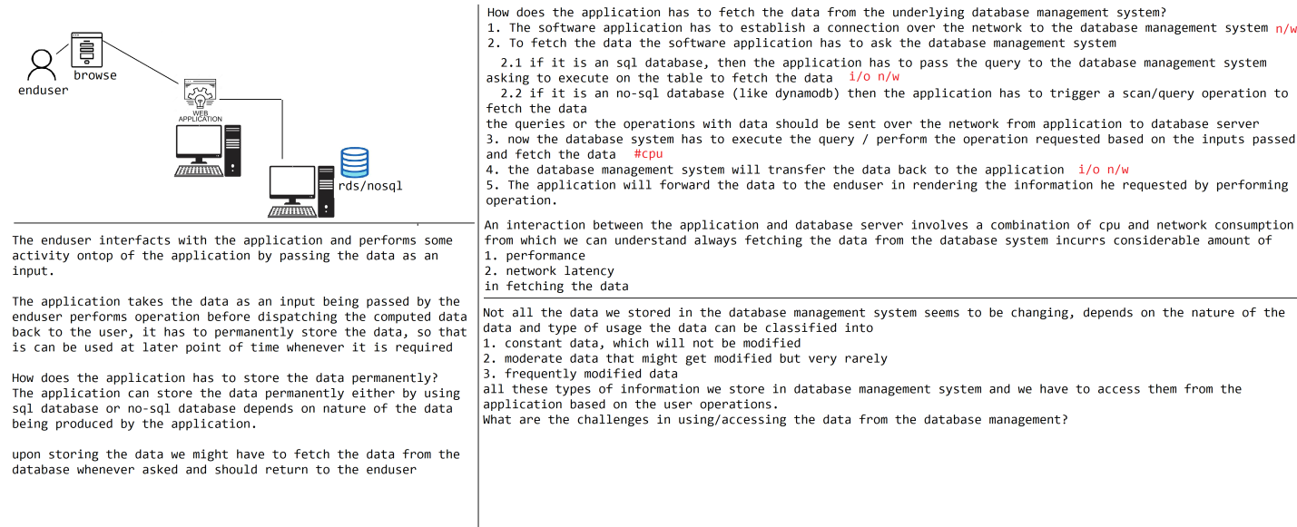

How does the application will persist or fetch the data from database management system?

Each application upon performing the operation will generates data as an ouput, the application should be able to persist the data into the database management system permanently for future usage, unless otherwise we cannot reuse the data in computing various different operations on the data

In order for an application to persist the data into the underlying database it has to perform the below activities

1. the application should establish a connection/open connection to the underlying database

2. the application has to pass the sql query asking the database to perform operation over the network

3. the database will parse the sql query and performs an relevant operation on the underlying data

4. the output of executing the sql query should be send back to the application over the network

5. the application will close the connection to the database

We store the business data that is produced out of the application into the database management system. Not all the data we stored in the underlying database management system will keep changing. There is some amount of data that seems to be static or constant in nature either permanently or for certain amount of time.

Let us try to understand the nature of data based on usecases:

#1. The information about the merchants stored in an e-commerce platform will change very rarely which is an example of static data

#2. The board/university publishes the results of an examination being conducted by storing the data into the database. once the results are announced, no matter how many number of times we are acessing the data, it will never change which is an example of static data

#3. The product information that is added into an ecommerce application by the merchange will seems to be remain constant for longer amount of time and may undergo changes very rarely which is another example of static data

#4. There is a tour planner who has organized an trip and the information about the trip has been published through their application by storing it in the database. once the tour planner publishes the information about a trip, it will remains constant and will never change

Here we have understood most of the data seems to be permanent/remains constant in nature, let us explore uses cases on the data which might change at regular intervals of time

1. Daily Sales report:

The sales information pertaining to the products of a company should be stored into the database, so that the business team can pull insight full information regarding how does the business is operating by deriving the sales dashboards/reports.

But the information about the sales will not keep-on changing rather they would be modified at regular intervals of time.

Frequently modified data

1. Stocks information within a stock market will be keep changing quite frequently which is an example of frequently modified data

An application has to store the business data within the database for future usage and further processing.

Not all the data that is being stored as part of the database of the application will be keep changing. There can be few data that seems to static/constant permanently or certain interval of time.

Let us explore the usecases pertaining to the nature of data:

#1 static data

1.1 an examination results published by the university or educational board seems to be constant/static permanently and will never undergo changes

1.2 upon adding an merchant in the e-commerce website, the information about the merchant seems to be almost constant/static and very rarely it might change

1.3 a product that is being added by an merchant into an ecommerce website seems to be constant and may undergo changes very rearly

1.4 Tour planner publishes the information about the tour packages into the application database and would not change the information unless required (very rarely)

#2. moderately modified at regular intervals of time

2.1 For eg.. an shippment being routed by an cargo service provider or courier provider. once the parcel has been dispatched until it arrives to the next destination the information/status of the parcel will not be changed and remains constant for most of the time

#3. frequently modified data

Leader boards

In a gaming application based on the points secured by the players the leaders board are drawn showing the position of the player among the other players in the world. here the points will be keep on changing for the different players and the leader board with ratings/rankings will change very frequently which is considered as frequently modified data

Let us understand how can the application can handle these various data of different nature

#1 static data

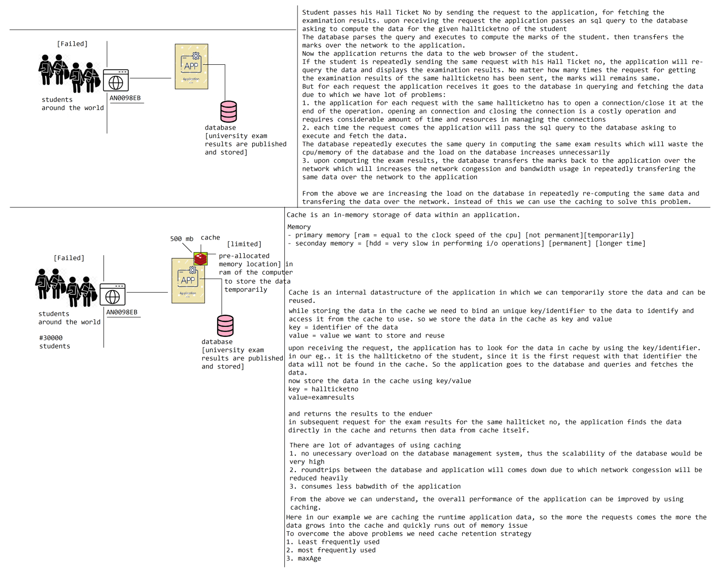

There are 6 features are there in spring boot

1. auto configurations

2. starter dependencies

3. actuator endpoints

4. devtools

5. embedded servlet containers

6. spring boot cli

4. devtools

devtools helps the developers in sophisticated developing the application while working with spring boot.

during the time of development of the application, developer goes in cycles in debugging and modifying the code multiple times. each time the developer modifies the code, he has to recompile, repackage and redeploy the application by restarting the server.

The amount of time the developer would spend in debugging the application would be quite high that is where devtools comes to rescue us

each time the developer modifies the code during executing the devtools identifies the modified class file and reloads the classfile into jvm memory by replacing the old copy of the class file thus reflecting the changes

hence we dont need any repackage, redeploy and restart of the server thus saves huge amount of development time

#5. embedded servlet containers

while working with servlet / spring mvc based applications we need to have servlet containers installed and configured on the target environments in which we are going to deploy the application.

In an microservices world the application is broken down into smaller microservices and deployed independently from each other, which means each mircroservice has to be deployed and executed on its own jvm or servlet container environment. So the time it takes to setup/configure the container to make the microservices application execute takes lot of time.

Instead to rescue us from the above problem, embedded servlet containers are introduced. The container is shipped as part of the code itself so we dont need to install, package and deploy the application on the server rather we can directly execute the application on the server like a regualar java application

#6. spring boot cli

we can quickly build the prototypes and verify them by using spring boot CLI. we dont need to create the projects, declare configurations etc

directly implement the functionality we wanted to experiment or expore by leaving the rest of the aspects of running the application to the SpringBoot CLI

we can write and run directly an class itself on a container without any deployment or configuration

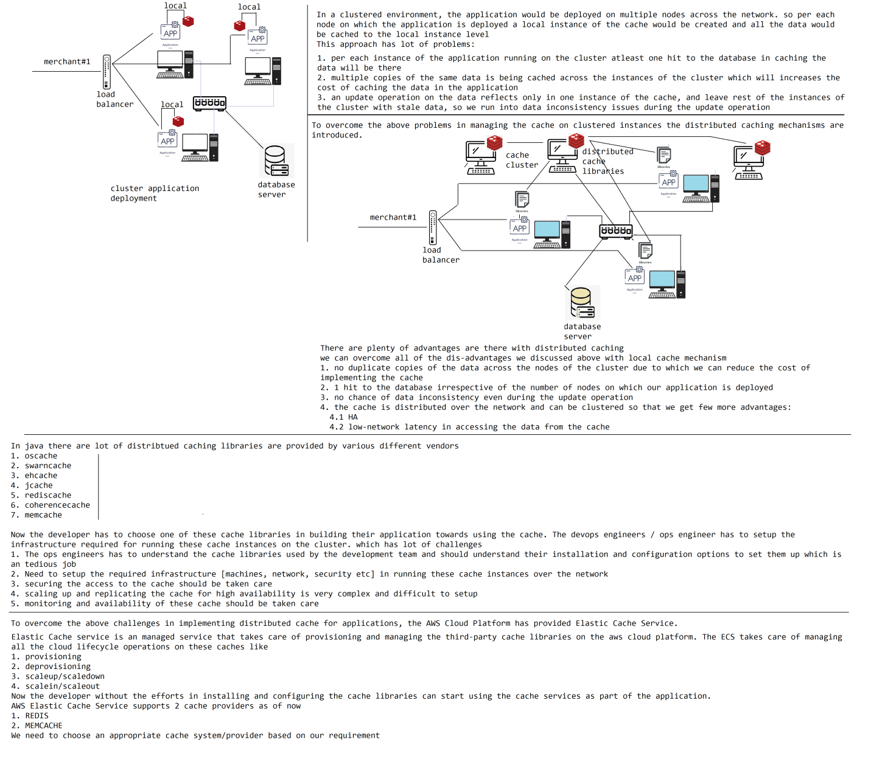

1. static data

2. moderate modified data

3. frequently modified data

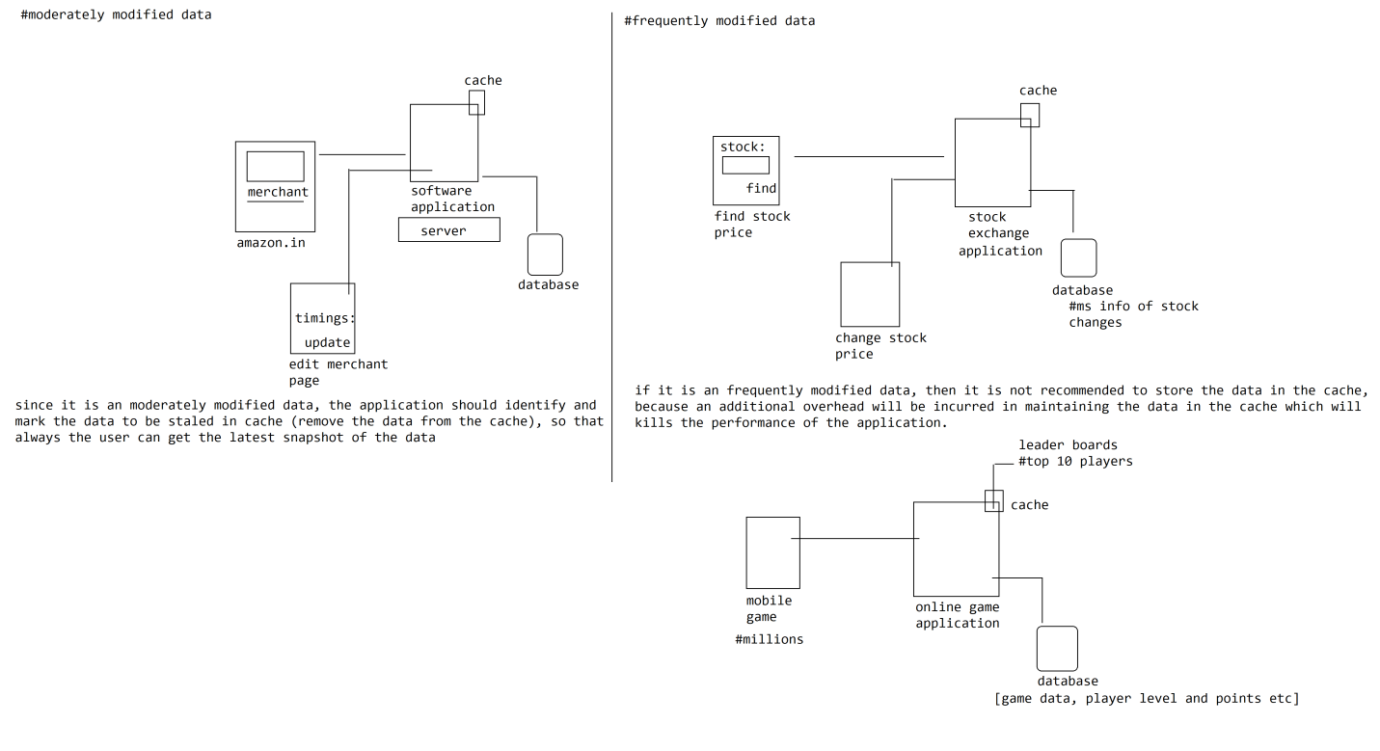

We can classify the data into 3 types

1. static data

2. moderate data

3. frequently modified data

#1. static data

The static data is nothing but throughtout the lifetime of the application the data will not change, and will not grow. So, it is an good candidate for caching

#2. moderate data

Moderate data seems to be most of the time fixed but would rarely going to change or might grow during the runtime of the application. since the data is runtime and may modify during the execution of the application we need to cache the data based on below 2 characteristics

1. we need to apply retention policy while storing the data into the cache like TTL, LRU, MRU, MFU, LFU algorithms

2. whenever the application has modified the data into the database, we should have a mechanism in place to remove the data from cache if exists

#3. frequently modified data

Frequently modified data is the data that would gets modified very frequently through the endusers operations on the application. Such data is not being considered as a candidate for cache, because the cost of maintaining the data in the cache seems to be overhead than using the data from cache.

But there is an exception to this, for eg.. applications like

1. gaming

2. stock markets

3. sales reporting

where the frequency at which we access the data seems to more than the duration of interval in which the data would be changed. So such data if it is being used more frequently than the interval change can be cached for short-interval of time

1. we should maintain TTL or any retention algorithms in cleaning up the data

2. and should stale the data whenever there is change

How about maintaining the data in the cache within the cluster deployments?

What is cache, why do we need caching?

Cache is used for storing the data temporarily within the memory, so that we can avoid repeatedly accessing the data from the database and serve the data from the cache. By applying the caching mechanism we can improve the scalability & performance of the application

depends on the nature of the data and their usage we need to decide and cache the data within the application

1. static data = always can be cached permanently within the application

2. moderate data = since it is runtime data, that should be cached based on retention policy and should mark the data as stale whenever the underlying data has been modified

3. frequently modified data = it is not an good candidate for caching, but can be considered to be cached given if the frequency at which the data is accessed is more than the interval of change then we can cache the frequently modified data as well.

when we are deploying an application in clustered environment, we need to use distributed caching technology for caching the data. There are lot of third-party caching libraries provided by various different vendors

1. ehcache

2. jcache

3. swarncache

4. rediscache

5. memcache

6. oscache

7. coherence cache

The developer writes the code as part of his application using the cache libraries/apis in caching the data, whereas the devops/aws cloud engineer has to

1. provision the infrastructure

2. install and configure the cache libraries

3. take of securing aspects in ensuring the cache is not comprimised

4. scalability, high availability

5. monitoring

taken care in managing the cache

manually taking care of provisioning, installing, configuring and maintaining the cache on the clustered instances over the network is a very difficult job. The aws cloud platform has provided Elastic Cloud Cache service

Elastic Cloud Cache service

-----------------------------

The Elastic Cloud cache service is an managed service that takes care of provisioning, installing, configuring and managing the third-party caching libraries on aws cloud platform, which is similar to RDS service.

As of now there are 2 cache library providers are supported by Elastic cloud cache

1. REDIS

2. MEMCACHE

There are differences interms of features between these 2 cache libraries, so based on the requirement we need choose an appropriate provider that suites our application

1. Mem Cache: supported data types: simple key/value pair

Redis Cache: supported data types: complex types which includes lists, sets, hashes and sortedset etc

2.

Mem Cache: Multi-thread support

Redis Cache: No Multi-thread support

3.

Mem Cache: Node upgrade is not supported (we cannot change the shape of the CacheNode)

Redis: Node shape upgrade is supported

4.

Engine upgradation: both providers support engine version upgrade

5.

Mem Cache: Replication is not supported, so fault-tolerance is not there

Redis: Replication is supported, so high availability is guaranteed

6.

Mem Cache: Data Partition and shrading is supported

Redis Cache: No support for data partition

7.

Mem Cache: doesnt support automatic fail-over

Redis: Optional can be configured

8.

Mem Cache: No support for publish/subscriber model

Redis: supports publish/subscriber model

9.

Mem Cache: supports huge volumes of data to be cached

Redis: doesnt support huge volumns of data to be cached

10.

Mem Cache: no back and restore support

Redis: backup and restore is available

How to provision an AWS Elastic Cache?

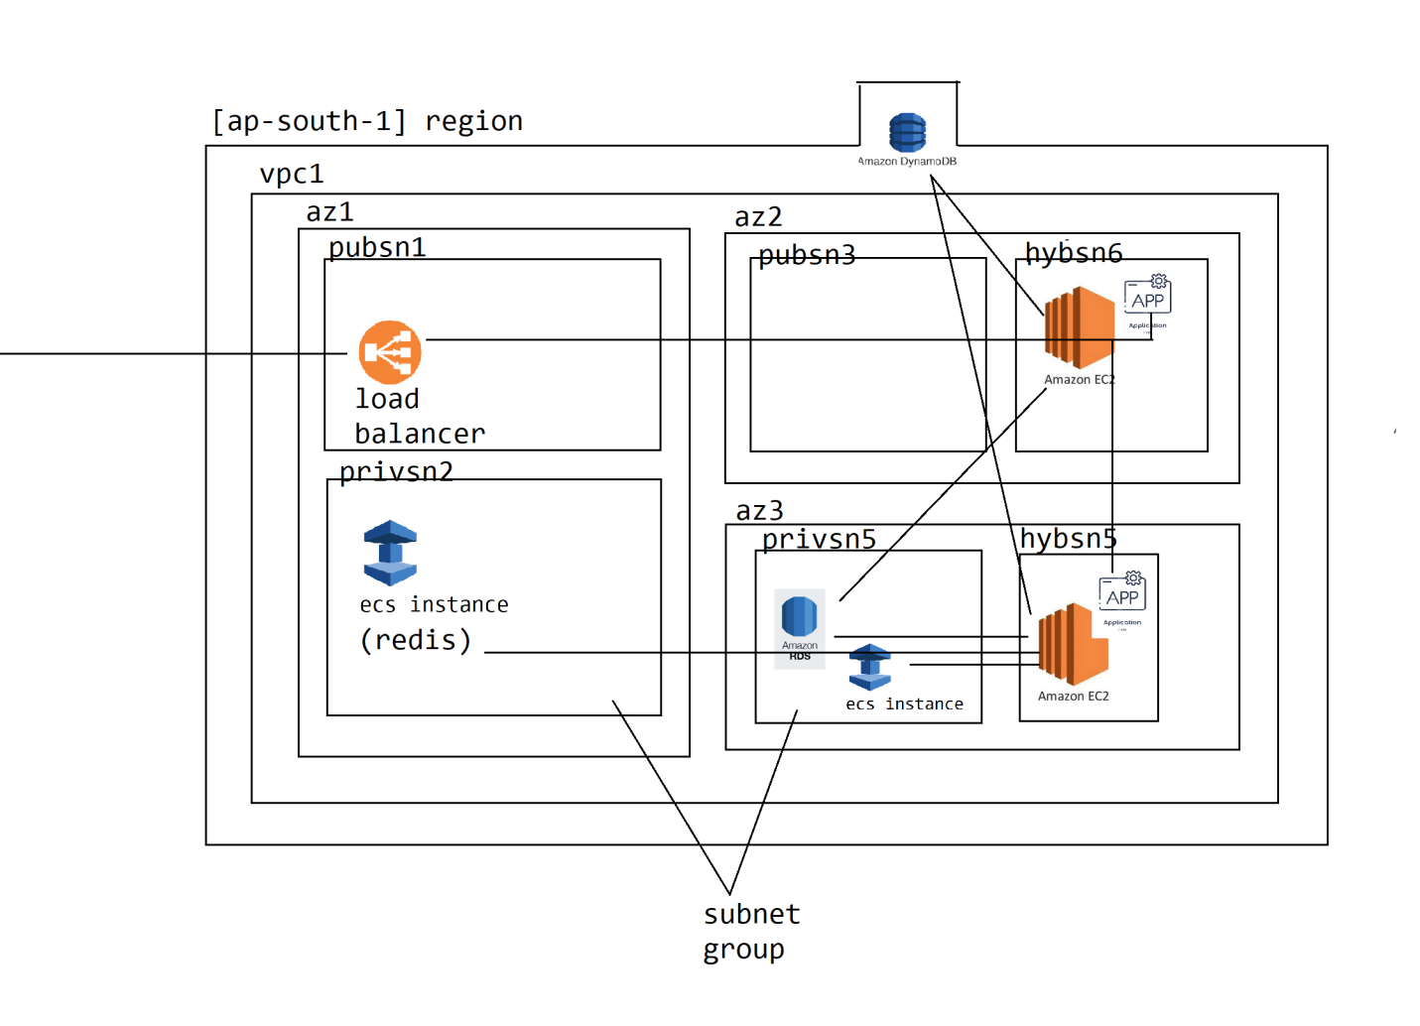

How to provision an elastic cache (redis) on aws cloud platform?

Elastic Cache is an vpc scoped service, we access the cache only from the applications. The applications are deployed on compute instances (ec2) of the cloud platform. So inorder to make the cache accessible across all the instances of the application we need to provision the cache on vpc network of the application.

#1 since we access the cache only from the application, and should not let the cache accessed from public network we need to provision the elastic cache instance on private subnet of the vpc

#2 By default AWS Cloud platform creates 2 replicas of the Elastic Cache for fail-over and fault-tolerance, so we need to create an subnetgroup in replicating the cache

#3. While setting up the subnet group it is recommended to distribute across the AZs of the region so that high-availability is guaranteed

#4. upon provisioning the elastic cache, to verify the cache is working or not we need to consume it by placing the message/data and access it back.

since we are not application developers, we can verify the cache and its connectivity by provisioning an ec2 instance on public subnet, install redis-tool on ubuntu operating system, using which we can connect to cahe and verify

once we verified the cache configuration we can share the endpoint of the cache to the developers to let them integrate within their application

-----------------------------------------------------------------------------------------------------------------------

#1 create an vpc

vpcname: gooddealsvpc

cidr: [10.0.0.0/16]

#2.

we need 3 subnets as per the above plan

2 = private subnets for HA

1 = public subnet

2.1

gooddealspubsn1

cidr: 10.0.1.0/24

2.2

gooddealsprvsn2 | gooddealsprvsn3

10.0.2.0/24 10.0.3.0/24

#3.

create an internet gateway (gooddealsig) and attach to the vpc

#4 route the public network traffic of that subnet throught the ig by associating through routetable

#5

create 2 security groups

5.1 ec2 instance to allow public ssh access

5.2

securitygroup: gooddealsecsg

in-bound: 10.0.0.0/16 6379 allow

out-bound: 0.0.0.0/0 anyport allow

#6 we need to create elastic cache

How to provision an elastic cache on aws cloud platform?

1. The cache is used as part of application only in general, so the elastic cache should be provisioned within the private subnet of the application vpc.

2. by default aws cloud platform provisions the multiple replicas of cloud cache for fault tolerance & fail-over safe we need to create subnet group to provision the cloud cache

3. after provisioning to verify the cache before delivering to the developers we need to provision an ec2 instance on public subnet and install redis-tools (redis-cli) using which connect to the cache and verify the instance

#1. create an vpc

vpc name: gooddealsvpc

cidr: 10.0.0.0/16

#2. create 2 private subnets & 1 public subnet

1 public subnet

gooddealspubsn1 [10.0.1.0/24]

2 private subnet

gooddealsprvsn2 [10.0.2.0/24]

gooddealsprvsn3 [10.0.3.0/24]

#3 create an internet gateway and attach to the gooddealsvpc

internet gateway: gooddealsig

attach to : gooddealsvpc

#4 route the public network traffic of the subnet through the ig by creating route table

gooddealsigrt

10.0.0.0/16 local

0.0.0.0/0 gooddealsig

#5 create 2 security groups

1. allow ssh access to the ec2 instance for connecting to the cache

2. allow elastic cache port to be accessed within the vpc

gooddealsec2sg

in-bound

SSH 22 0.0.0.0/0 allow

outbound

ALL ANY 0.0.0.0/0 allow

gooddealsecsg

inbound

Custom TCP 6379 10.0.0.0/16 allow

outbound

ALL ANY 0.0.0.0/0 allow

we setup network infrastructure required for hosting/provision an elastic cloud cache, let us understand the steps for provisioning the cache

1. choose the cache engine we want to provision the cache cluster

1.1 redis

1.2 memcache

2. Choose Cluster Mode

2.1 enable = cluster mode enables replication across multiple shards for enhaced scalability and availability

2.2 disable = The Redis cluster has only one shard with one primary node and upto 5 read replicas

3. Cluster Info

3.1 Name

3.2 description

3.3 Location

AWSCloud or OnPremises

3.4 Multi-AZ

3.5 Engine Version

3.6 Port

3.7 NodeType (Shape)

3.8 number of replicas

3.9 subnet group settings

1. choose the AZ and Subnets under which the replicas has to be created

2. choose vpc

3.10 Backup configuration

3.11 encryption settings

3.12 Maintainance Window

3.13 choose security group

3.14 add tags

3.15 create

------------------------------------------------------------------------------------------------------------------------

Launch Ec2 instance to test and verify the cache configuration

1. provision an ec2 instance with ubuntu operating system

2. update and install redis-tools software package using ubuntu apt

sudo apt update -y

sudo apt install -y redis-tools

3. copy the primary endpoint of the elastic cache that we provisioned above and use redis-cli to connect and verify the cache

4. redis-cli -h endpoint -p portNo

5. set key value = to store data into the cache

6. get key = to access the data from the cache

7. key * = to see all the keys in the cache

8. ping = to verify connectivity with the cache

How to provision an elastic cache on aws cloud platform?

1. The cache is used as part of application only in general, so the elastic cache should be provisioned within the private subnet of the application vpc.

2. by default aws cloud platform provisions the multiple replicas of cloud cache for fault tolerance & fail-over safe we need to create subnet group to provision the cloud cache

3. after provisioning to verify the cache before delivering to the developers we need to provision an ec2 instance on public subnet and install redis-tools (redis-cli) using which connect to the cache and verify the instance

#1. create an vpc

vpc name: gooddealsvpc

cidr: 10.0.0.0/16

#2. create 2 private subnets & 1 public subnet

1 public subnet

gooddealspubsn1 [10.0.1.0/24]

2 private subnet

gooddealsprvsn2 [10.0.2.0/24]

gooddealsprvsn3 [10.0.3.0/24]

#3 create an internet gateway and attach to the gooddealsvpc

internet gateway: gooddealsig

attach to : gooddealsvpc

#4 route the public network traffic of the subnet through the ig by creating route table

gooddealsigrt

10.0.0.0/16 local

0.0.0.0/0 gooddealsig

#5 create 2 security groups

1. allow ssh access to the ec2 instance for connecting to the cache

2. allow elastic cache port to be accessed within the vpc

gooddealsec2sg

in-bound

SSH 22 0.0.0.0/0 allow

outbound

ALL ANY 0.0.0.0/0 allow

gooddealsecsg

inbound

Custom TCP 6379 10.0.0.0/16 allow

outbound

ALL ANY 0.0.0.0/0 allow

we setup network infrastructure required for hosting/provision an elastic cloud cache, let us understand the steps for provisioning the cache

1. choose the cache engine we want to provision the cache cluster

1.1 redis

1.2 memcache

2. Choose Cluster Mode

2.1 enable = cluster mode enables replication across multiple shards for enhaced scalability and availability

2.2 disable = The Redis cluster has only one shard with one primary node and upto 5 read replicas

3. Cluster Info

3.1 Name

3.2 description

3.3 Location

AWSCloud or OnPremises

3.4 Multi-AZ

3.5 Engine Version

3.6 Port

3.7 NodeType (Shape)

3.8 number of replicas

3.9 subnet group settings

1. choose the AZ and Subnets under which the replicas has to be created

2. choose vpc

3.10 Backup configuration

3.11 encryption settings

3.12 Maintainance Window

3.13 choose security group

3.14 add tags

3.15 create

------------------------------------------------------------------------------------------------------------------------

Launch Ec2 instance to test and verify the cache configuration

1. provision an ec2 instance with ubuntu operating system

2. update and install redis-tools software package using ubuntu apt

sudo apt update -y

sudo apt install -y redis-tools

3. copy the primary endpoint of the elastic cache that we provisioned above and use redis-cli to connect and verify the cache

4. redis-cli -h endpoint -p portNo

5. set key value = to store data into the cache

6. get key = to access the data from the cache

7. key * = to see all the keys in the cache

8. ping = to verify connectivity with the cache

------------------------------------------------------------------------------------------------------------------------